**What is the difference between LAN-free and serverless backup?**

This is a Q&A from [SAN School Lesson 8](http://searchstorage.techtarget.com/originalContent/0,289142,sid5_gci943556,00.html).  
Click here for more [SAN School lessons](http://searchstorage.techtarget.com/originalContent/0,289142,sid5_gci931319,00.html).

[LAN-free](http://searchstorage.techtarget.com/tip/1,289483,sid5_gci884690,00.html) backup usually involves the ability to share a SAN connected tape library between all the nodes connected in the SAN. The backup server simply coordinates access to the tape resources. Each server in the SAN actually runs a copy of the backup engine and moves its own data to tape. This is sometimes called the "SSO" or shared storage option from some backup vendors. The [backup](http://searchstorage.techtarget.com/originalContent/0,289142,sid5_gci951268,00.html) server becomes the traffic cop for the SAN connected tape resources and allows each server in the [SAN](http://searchstorage.techtarget.com/gDefinition/0,294236,sid5_gci212937,00.html) to back up its own data. This removes the need to "PULL" data over the [LAN](http://searchstorage.techtarget.com/gDefinition/0,294236,sid5_gci212495,00.html) via backup agents to a backup server connected tape resource.

[Serverless backup](http://searchstorage.techtarget.com/ateQuestionNResponse/0,289625,sid5_cid543863_tax286189,00.html) is accomplished by the backup server having the ability to connect to storage on behalf of other hosts connected to the SAN and back up that host's storage on its behalf. This usually involves the use of [snapshot](http://searchstorage.techtarget.com/infoCenter/tip/0,294276,sid5_gci940243_tax294585,00.html) or image copies of the production LUNs in the SAN. The snapshot is used as the source media for backup so that the production application can continue during backup. The snapshot is given access through [LUN](http://searchstorage.techtarget.com/gDefinition/0,294236,sid5_gci347534,00.html) security in the SAN for access by the backup server,and the backup server sends the data to tape.

Another method is to use the SCSI extended copy command called E-Copy which allows even the backup server to get out of the backup path. E-copy allows data to move directly from disk to tape via a "data router" which provides the E-copy intelligence.

Chris

**Do you want server-free or LAN-free backup?**

**Rick Cook**

* [E-mail](http://searchstorage.techtarget.com/tip/Do-you-want-server-free-or-LAN-free-backup)
* [Print](http://searchstorage.techtarget.com/tip/Do-you-want-server-free-or-LAN-free-backup?vgnextfmt=print)
* [A](http://searchstorage.techtarget.com/tip/Do-you-want-server-free-or-LAN-free-backup)
* [AA](http://searchstorage.techtarget.com/tip/Do-you-want-server-free-or-LAN-free-backup)
* [AAA](http://searchstorage.techtarget.com/tip/Do-you-want-server-free-or-LAN-free-backup)
* [LinkedIn](http://searchstorage.techtarget.com/tip/Do-you-want-server-free-or-LAN-free-backup)
* [Facebook](http://searchstorage.techtarget.com/tip/Do-you-want-server-free-or-LAN-free-backup)
* [Twitter](http://searchstorage.techtarget.com/tip/Do-you-want-server-free-or-LAN-free-backup)
* [Share This](http://searchstorage.techtarget.com/tip/Do-you-want-server-free-or-LAN-free-backup)
* [Reprints](http://reprints.ygsgroup.com/m/techtarget)

Even though the terms have been commonly used for several years, there is still some confusion between LAN-free and server-free backup. In part this is because server-free backup is seen as a 'hotter' technology that promises better performance, so vendors want to refer to their approach as 'server-free' backup.

Both approaches use high-speed connections, such as Fibre Channel, and both can significantly improve the performance of tape backups when compared to conventional backup approaches. LAN-free backup connects the tape backup subsystem to the disk subsystem by a direct connection such as Fibre Channel Arbitrated Loop. This high-speed connection can transfer data at much greater than LAN speeds. LAN-free backup is usually the less expensive approach, especially when existing hardware such as tape drives can be reused.

In server-less backup a separate device takes over the job of transferring the data from the disks to the tape over the high-speed link. In effect it adds a controller, such as a Fibre Channel router or a blade in a Fibre Channel switch, to the LAN-free backup system to handle the job of moving data. The server simply acts as an overall coordinator rather than issuing the commands to move the blocks or files itself. Server-less backup provides a performance improvement over LAN-free backup, but the incremental improvement is less than what is gained by going from conventional to LAN-free backup. Server-less backup is also more expensive and

<http://searchstorage.techtarget.com/tip/Do-you-want-server-free-or-LAN-free-backup>

<http://www.infostor.com/index/articles/display/66784/articles/infostor/volume-4/issue-4/features/lan-free-server-less-backup-benefits.html>

# LAN-free, server-less backup benefits

## Posted on April 01, 2000

**Storage area networks allow you to offload backup processing from the primary network and host systems.**

By Ron Levine

As more and more data is committed to mission-critical applications, backup has taken on an increasingly important role in IT operations. Currently, backups are typically accomplished over a LAN to a tape library. Until recently, that approach worked adequately for most organizations, but the Internet and other business-critical applications such as enterprise resource planning (ERP) and data warehousing have brought backup to a new level-one in which 24x7 operation and globalization are the norm.

"Organizations are looking for storage options that optimize the storage space available today, but can be expanded in the future. And they're looking for backup solutions that don't saturate the LAN," notes Scott Robinson, chief technology officer at Datalink Corp., a systems inte grator and networked data storage provider (www.datalink.com).

|  |
| --- |
| [[http://images.pennnet.com/articles/is/thm/th_0004islevine1a.gif](javascript:OpenLargeWindow(265014,650,666,'IS');) Traditional backup clogs LAN: Data is backed up over the production network via dedicated backup servers.](javascript:OpenLargeWindow(265014,650,666,'IS');)  [Click here to enlarge image](javascript:OpenLargeWindow(265014,650,666,'IS');) |

The most common backup approach is to back up data to dedicated tape drives or to increase LAN bandwidth and dedicate a server to the backup function. The first is time-consuming, not to mention impractical; the second is a short-term fix due to scalability issues.

|  |
| --- |
| [[http://images.pennnet.com/articles/is/thm/th_0004islevine1b.gif](javascript:OpenLargeWindow(265014,650,666,'IS');) SAN delivers server-less backup: Tape drives can be dynamically allocated and de-allocated across servers.](javascript:OpenLargeWindow(265014,650,666,'IS');)  [Click here to enlarge image](javascript:OpenLargeWindow(265014,650,666,'IS');) |

In either case, network bandwidth is used to transfer large volumes between systems and backup devices, "squeezing out" other LAN traffic. For smaller businesses, especially those that do not need continuous client access, these backup methods work well, but as more data is acquired these volumes can impinge on client functions and slow response time, especially with applications such as ERP, OLTP, and Web hosting.

|  |
| --- |
| [[http://images.pennnet.com/articles/is/thm/th_0004islevine1c.gif](javascript:OpenLargeWindow(265014,650,666,'IS');) Software enables shared libraries: Individual tape drives are dedicated to tape libraries. Media management is controlled by the master backup server or a separate media management server.](javascript:OpenLargeWindow(265014,650,666,'IS');)  [Click here to enlarge image](javascript:OpenLargeWindow(265014,650,666,'IS');) |

A better answer is a storage area network (SAN). A dedicated network specifically de-signed for data storage functions, a SAN enables enterprise-wide backup functions to take place "off" the LAN (hence the term "LAN-free"). In doing so, the LAN network is free to continue communication chores without sluggishness or disruptions, even during extensive data transfers. "A SAN is an ideal network for large-scale backups," states Robinson.

LAN-free backup can occur at Fibre Channel data rates (100MBps), compared to LAN rates (frequently less than 10MBps). Also, by removing the backup task from the LAN, bandwidth is increased, which enables applications to run more efficiently. And, lastly, because SANs are scalable, they can be easily expanded as storage requirements grow while retaining centralized management of storage devices.

There are several levels of LAN-free backup. Today, basic LAN-free technology is available. It consists of shared tape libraries with dedicated connections to individual servers over a SAN. Also available is backup software that enables multiple servers to dynamically share drives. The software allows drives to be allocated and de-allocated among multiple servers as needed, rather than on a one-to-one or many-to-one basis. This results in the need for fewer drives and libraries, and it shortens the backup window since more drives can be designated to a specified backup task.

Like direct-attached SCSI environments, basic LAN-free technology uses a shared library approach in which individual tape drives are dedicated to specified servers. Traditional SCSI connections are replaced with Fibre Channel connections, and data moves directly from application and file servers to backup devices over the SAN.

One advantage of this method is Fibre Channel's 100MBps bandwidth, which can be scaled to hundreds of megabytes per second in switched Fibre Channel environments. (Intelligent switches provide connectivity with increasing aggregate bandwidth as backup devices are added.)

Another advantage is Fibre Channel's ability to cover greater distances than SCSI (10km versus 25m). Since most disaster recovery plans involve storing large amounts of data miles away from primary facilities, backup tied to disaster recovery functions can benefit from Fibre Chan-nel's distance advantage.

Previously, there were only two op-tions: 1) to physically ship tapes to a secure building off-site or 2) to invest in costly WAN systems that are designed for messaging, not data transfer. By using channel extenders, seamless connection of Fibre Channel to ATM or T3 is now possible, extending the SAN over the WAN (SWAN). "This allows you to more simply and quickly achieve offsite storage of critical data for disaster recovery purposes," says Robinson.

In the near future, a new level of SAN backup will be available. It will include dedicated, lower-cost intelligent devices that can transfer blocks of data directly from primary storage (usually disk) to backup devices. Basically, the control involved in monitoring, processing, and moving data will be placed at the SAN in the form of a dedicated storage server.

Server-less (somewhat of a misnomer in the context of dedicated storage ser-vers) backup offers several advantages:

* The storage server is independent of the operating systems used for the general-purpose application and file servers, providing a cost-effective "thin server" dedicated to the management of data in the SAN.
* Disaster recovery is more efficient because data protection is independent of the general-purpose servers.
* The storage server centralizes data management.
* It will be possible to size the application and file servers for application functions, because they are free of backup and data protection tasks.
* Backups can be applied more broadly because data is now protected on the SAN. With server-free backup, it is much easier to consolidate and manage data.

SAN-based LAN-free and server-less backup technologies provide methodologies to accomplish backup and recovery in a more efficient, manageable, and scalable manner than traditional methods. In light of today's demanding IT requirements, it is a significant challenge to optimize backup performance while minimizing LAN saturation.

IT managers are discovering that by removing storage applications such as backup and recovery from the LAN and placing them onto a Fibre Channel-based SAN, LAN application performance can be improved, backup time reduced, and the impact of daily backups on the messaging network eliminated.

Ron Levine is a technology writer with Coast Writing, an independent firm specializing in computer application articles. He can be reached at ron@coastwriting.com.

For more information about LAN-free and server-less backup technologies, visit www.datalink.com/papers.

null

InfoStorArticle Categories:

|  |  |  |
| --- | --- | --- |
| [SAN - Storage Area Network](http://www.infostor.com/index/SAN.html) |  | [Disk Arrays](http://www.infostor.com/index/disk-arrays.html) |
| [NAS - Network Attached Storage](http://www.infostor.com/index/NAS.html) |  | [Storage Blogs](http://www.infostor.com/index/blogs.html) |
| [Storage Management](http://www.infostor.com/index/storage-management.html) |  | [Archived Issues](http://www.infostor.com/index/past-issues.html) |
| [Backup and Recovery](http://www.infostor.com/index/backup-and_recovery.html) |  | [Data Storage Archives](http://www.infostor.com/index/issue-archive.html) |

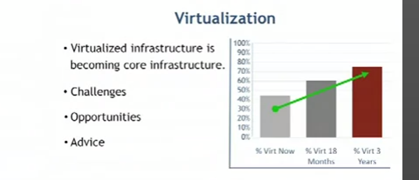

Challenges and opportunities for data availability

A virtual machine can do backup as any other device through agents at the machine

Multiple VM running multiple backup agents on a single server can quickly chew up memory

When looking for a backup software check:

-agent less backup?

-How Stores level snapshots

-Datadeduplication

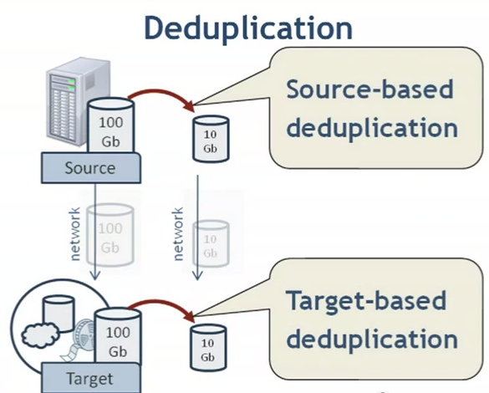

Source es nueva, en el backup agent esta en el server:

Esto trae: - more processing overhead

+ Menos datos se envían por la red

+ Reducir capacidad y requerimientos del backup

+ menos espacio usado

Enterprise storage

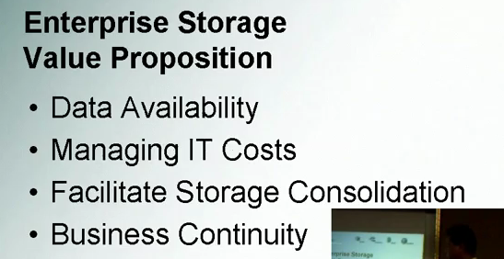

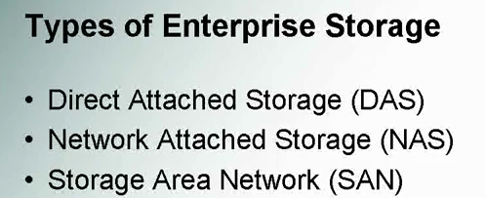

DAS: everyday storage. It’s on that device

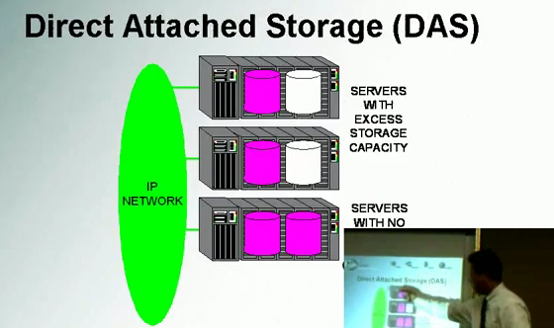additional capacity

The more servers, the worst managers

Used by small companies

.

NAS

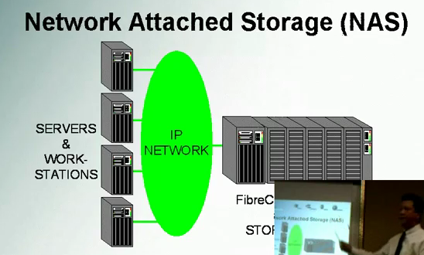

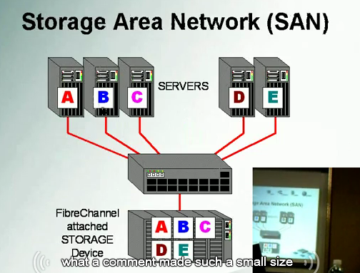

Si te quedas sin espacio en uno de los espacios asignados para cada aplicacion, se puede hacer drag & drop y tener espacio extra. No se colisinan entre si.

No hay downtime

+ No hay que preocuparse por almacenamiento en cada servidor.

“+ baja el costo de los servidores donde se alojan las aplicaciones” el storage se pone aparte

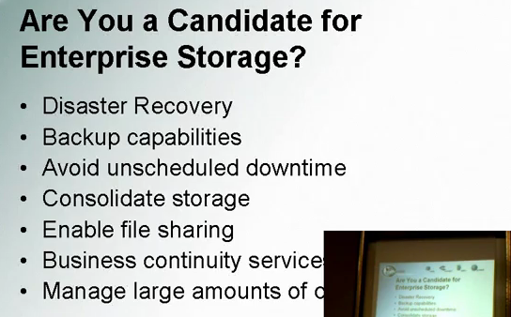

SAN

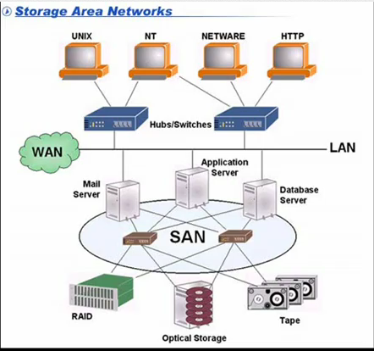

-red separada

-naranja son clients

-servidores son los que tienne la aplicación y l san esta debajo

<http://www.youtube.com/watch?v=J88X_M6s0l4&feature=related>

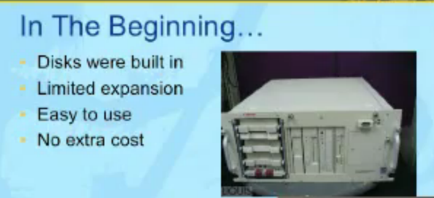

-no es muy expandible, limite de discos

-facil de usar

-habia costos extras, todo está dentro de la caja

Luego vino

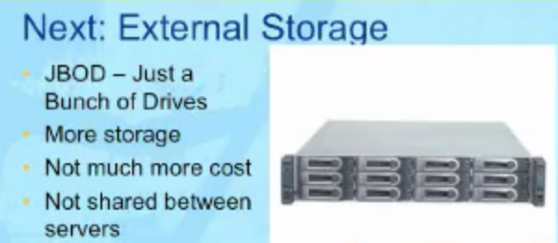

* No daba flexibilidad

Luego vino

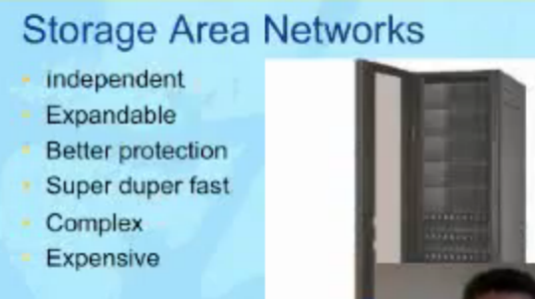

-varios racks

-podes asignar a un servidor uno o varios discos y asignarlos dinámicamente.

-mejor protección y más flexibilidad

-es más caro

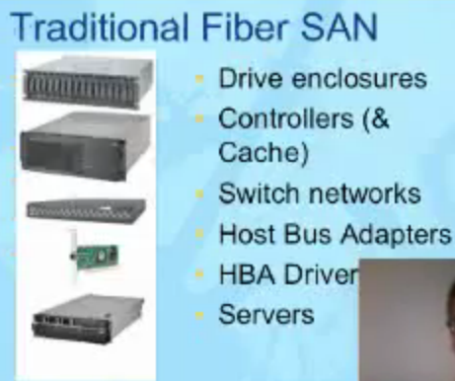

composicion

-Drive enclosures: cajas para drives

Para un tipo de discos en especiales.

-Luego tienen una controladora (son como servidores que manajan los discos)

-luego tiene los switches

-host bus adapters (son los equivalentes a las tarjetas de red de los servidores)

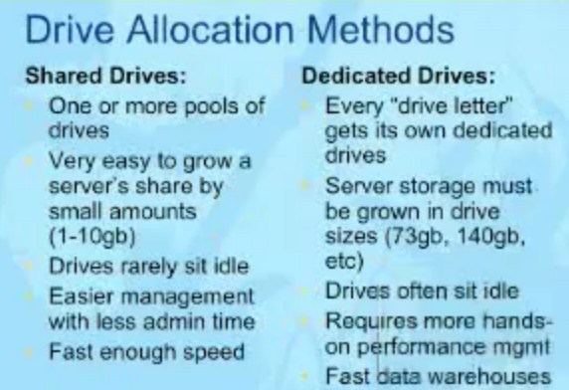

-dedicated drive no es tan eficiente, se aloca espacio que puede que no se necesite en este mismo instance. Hay muchos discos en “idle”

-tenes que ver la performance de cada disco (en dedicates)

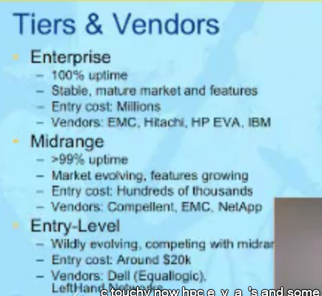

SAN snapshot backup

El controlador de la san lo maneja

Es un hw que lo hace. No network overhead

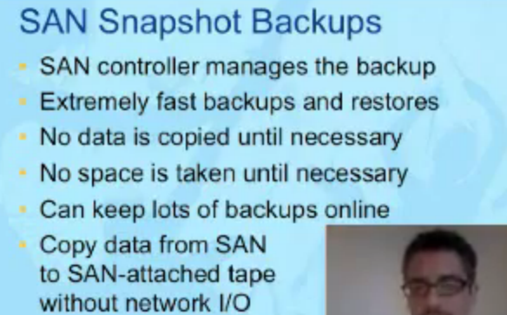

Es muy rápido.

No se ocupa espacio hasta que no es necesario

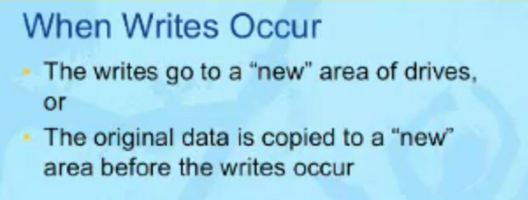

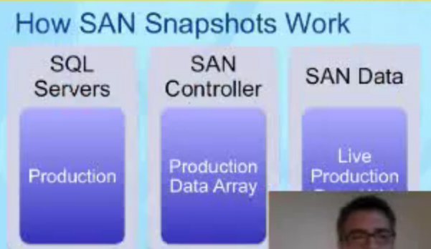

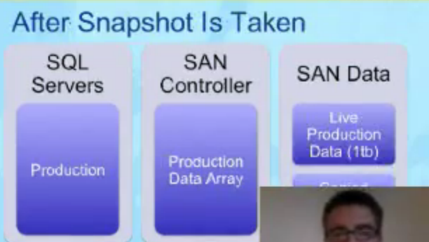

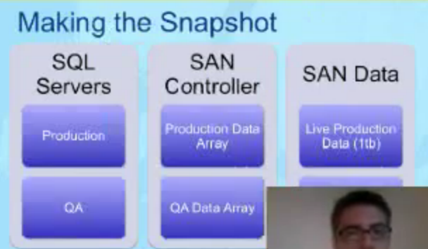

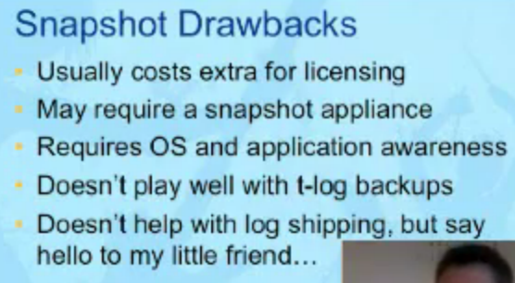

t-log: transaction log

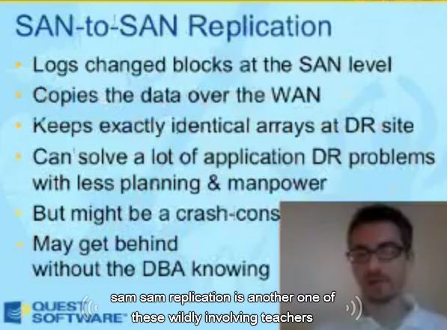

Da arrays idéntico.

DR= disaster recovery

<http://www.youtube.com/watch?v=PP5xK5N-o_M&feature=related>

5 essencial storage technologies : soluciones de almacenamiento de IBM

Real time compression





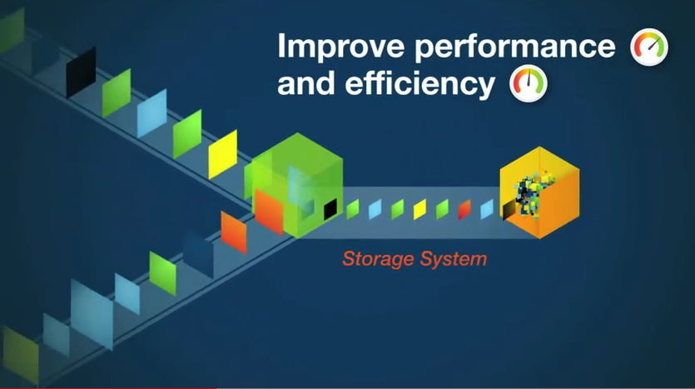

Remover reduncancia (data deduplication)



A través de algoritmos especiales, se detecta información dupblicada, dejando solo una copia de la informacion que se debe almacenar.

Virtualizacion de almacenamiento:

Se hace un “enmascaramiento” de las características físicas del almacenamiento a las aplicaciones

Permite movimiento de información on line entre distintos tipos de almacenamiento

+ flexibilidad

+ permite load balancing

+ optimiza costos de almacenamiento

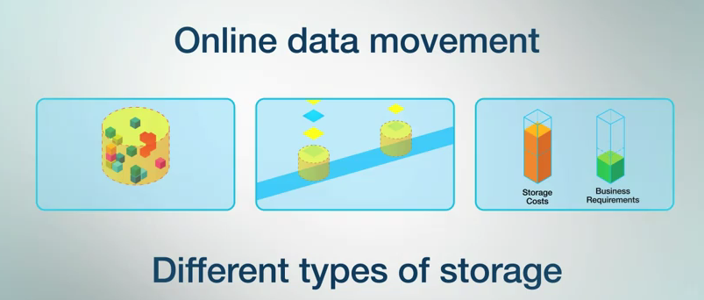

Thin provitioning

Enforque tradicional: se reserva espacio que no se va a usar

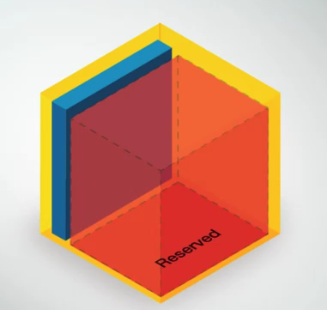

Vs

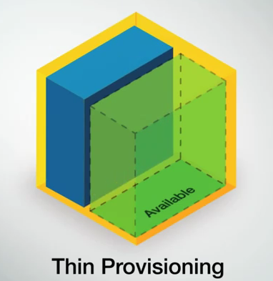

Que reserva espacio automáticamente y solo cuando se necesita

Permite mejorar la planificación de almacenamiento

-Automated tiering:

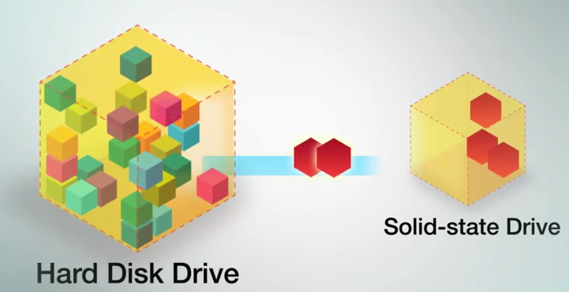

Permite que la información se mueva dinámicamente al tipo de drive apropiado de más performance, basado en monitoreo de la performance

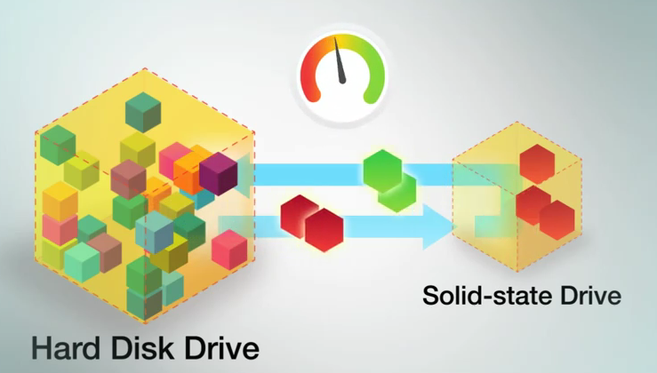

Se puede mejorar los datos que se acceden con mas frecuencia a discos de mayor performance (SDD)

<http://www.youtube.com/watch?v=lHiQdKb_3fo&feature=related>

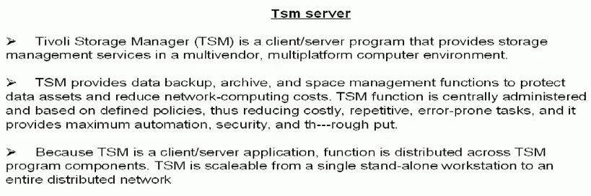

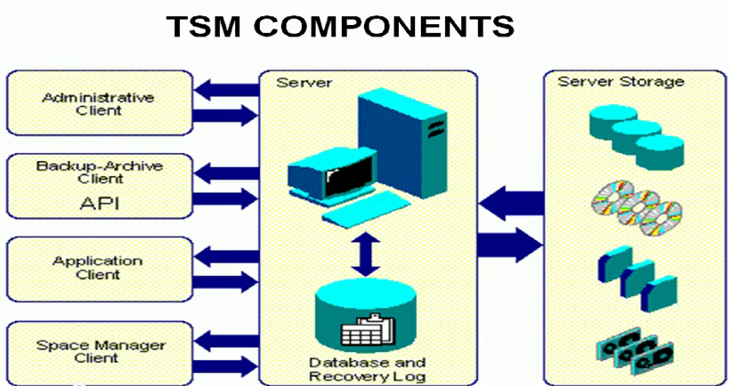

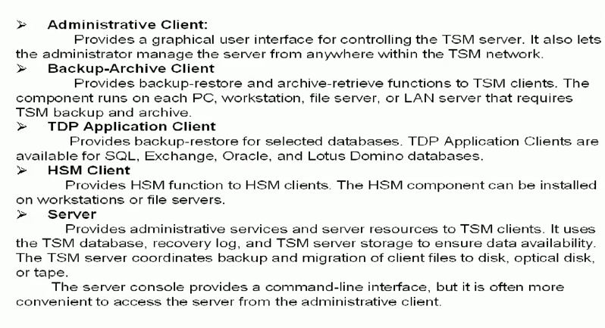

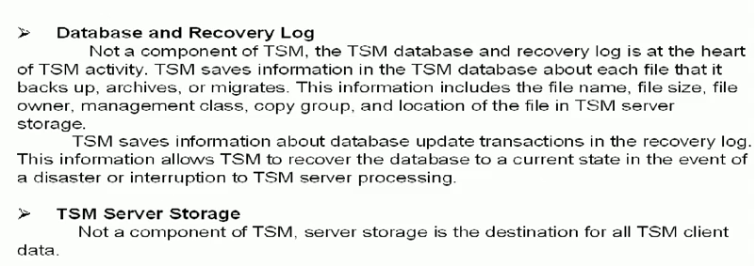

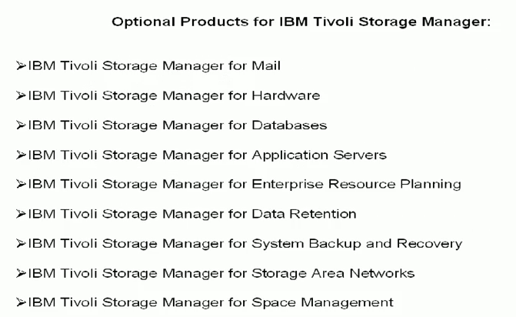

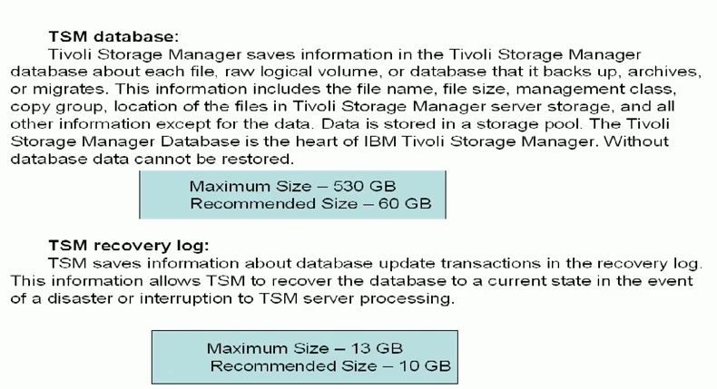

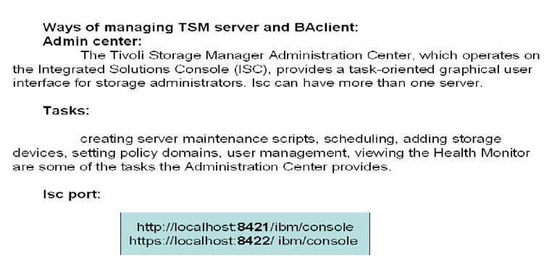

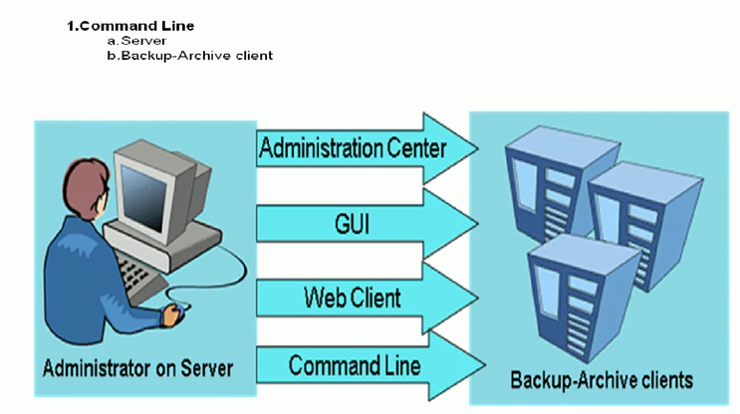

<http://www.youtube.com/watch?v=eZTDsJsCDXw>

pulse 2010 presentan version 6.2

-client id deduplication and server id deduplication

- client push ?

- simultaneous writing during migration???

<http://www-304.ibm.com/support/docview.wss?uid=swg27022951&aid=17>

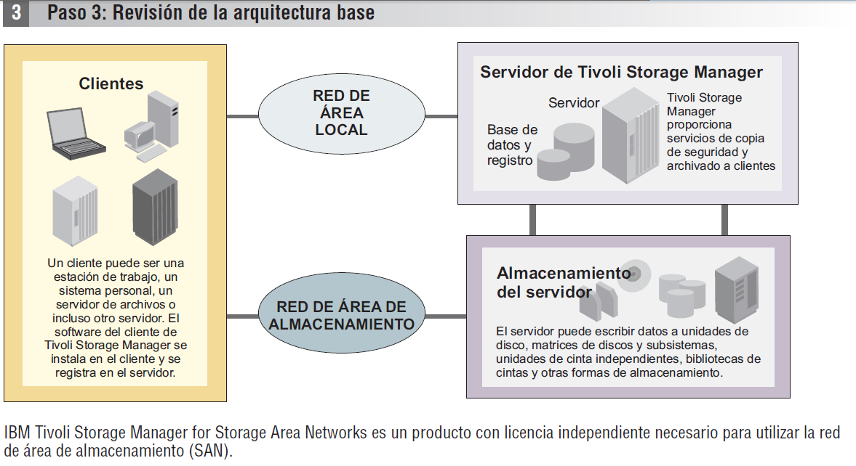

SO soportados

<http://www-304.ibm.com/support/docview.wss?uid=swg21243309>

|  |  |
| --- | --- |
| [**TSM Server and​**](http://www-304.ibm.com/support/docview.wss?uid=swg21243309#server_table) ​[**Storage Agent Platforms​**](http://www-304.ibm.com/support/docview.wss?uid=swg21243309#server_table)**​** ​  [AIX​](http://www-304.ibm.com/support/docview.wss?uid=swg21243309#aixpart) ​ ​[HP-UX​](http://www-304.ibm.com/support/docview.wss?uid=swg21243309#hppart) ​[Linux on POWER​](http://www-304.ibm.com/support/docview.wss?uid=swg21243309#linpart) ​  ​[Linux x86\_64​](http://www-304.ibm.com/support/docview.wss?uid=swg21243309#linx8664part) ​[Linux zSeries​](http://www-304.ibm.com/support/docview.wss?uid=swg21243309#zlinpart) ​[Solaris​](http://www-304.ibm.com/support/docview.wss?uid=swg21243309#solarispart) ​[Windows​](http://www-304.ibm.com/support/docview.wss?uid=swg21243309#winpart) | [**TSM Client Platforms​**](http://www-304.ibm.com/support/docview.wss?uid=swg21243309#TSMClientPlatforms) ​  ​  [AIX​](http://www-304.ibm.com/support/docview.wss?uid=swg21243309#client_aixpart) ​ ​[HP-UX Itanium​](http://www-304.ibm.com/support/docview.wss?uid=swg21243309#client_hpuxItanium) ​[Linux on POWER​](http://www-304.ibm.com/support/docview.wss?uid=swg21243309#client_linuxpower) ​[Linux X86\_64​](http://www-304.ibm.com/support/docview.wss?uid=swg21243309#client_x86linux) ​[Linux zSeries​](http://www-304.ibm.com/support/docview.wss?uid=swg21243309#client_zlinux) ​[Macintosh​](http://www-304.ibm.com/support/docview.wss?uid=swg21243309#client_macintosh) ​[Sun Solaris SPARC​](http://www-304.ibm.com/support/docview.wss?uid=swg21243309#client_solaris) ​[Sun Solaris x86 / x86\_64​](http://www-304.ibm.com/support/docview.wss?uid=swg21243309#client_solaris_x86) ​[Windows​](http://www-304.ibm.com/support/docview.wss?uid=swg21243309#client_windows) |
| ​ ​ | [z/OS Unix​](http://www-304.ibm.com/support/docview.wss?uid=swg21243309#client_os390) |

<http://www-01.ibm.com/software/tivoli/products/storage-mgr/product-features.html?S_CMP=wspace>

**IBM Tivoli Storage Manager features**

The IBM® Tivoli® Storage Manager (TSM) family of offerings offers a wide range of features supporting centralized, automated data protection that can help reduce the risks associated with data loss while helping to manage costs, reduce complexity and address compliance with regulatory data retention requirements.

Detailed information about these features including platform and version information is available online in IBM Tivoli Storage Manager publications.

| **IBM Tivoli Storage Manager features** | |
| --- | --- |
| Feature | Benefits |
| Active data storage pools | Allows optimized access to active versions for faster restores. The active version storage pools can be populated at backup time or after backups complete. |
| Active directory support | Provides for the un-deletion (reanimation) of objects from Active Directory's tombstone. |
| Administrator Center/ Administrator User interface | Task-orientated interface to manage one or more TSM servers |
| API | Allows for critical online backup services to data-intensive applications |
| Archive | Helps quickly and easily retrieve archived data, helping effectively extend your data storage capabilities without the need for more expensive online storage |
| Backup Sets (rapid restores or instant archives) | Provides the ability to create a backup set that consolidates a client's files onto a set of media that is portable and may be directly readable by the clients' system for fast, LAN-free (non-networked) restore operations |
| Bare Machine Restore (bare metal restore) | Restores the operating system of Windows, Sun™, Linux, HP and AIX |
| Central Administration | The Integrated Solutions Console (ISC) enables Unified Recovery Management across multiple Tivoli Storage Manager, Tivoli Storage Manager FastBack, Tivoli Storage FlashCopy Manager and Tivoli Storage Manager FastBack for Workstations instances. |
| Checksum | Adds an additional layer of data verification between the TSM server and client running in unstable hardware environments |
| Cluster Support | Support for HACMP®, Windows MSCS and Novell NCS |
| Collocation Groups | Takes the grouping of individual clients' data a step further by enabling you to specify that particular clients' data should reside on their own tape or set of tapes |
| Compression | Clients can choose to have their data compressed prior to being sent to the TSM server to help conserve bandwidth |
| Continuous Data Protection | Back up files the second they close or are saved |
| Data Shredding | Destroys sensitive data objects when deleted or moved, preventing undesirable data discovery. Data that resided in random access disk storage pools can be overwritten up to 10 times. |
| Deduplication | Source-side data deduplication reduces the amount of data sent over the network to the TSM Server. Post-process, target-side data deduplication at the TSM server reduces the capacity needed in disk storage pools. Both features use variable block-level techniques. |
| DB2® Online Backup | Makes use of our client API for backup and recovery without additional software or licensing requirement |
| Disaster Recovery Manager (DRM) | Creates a disaster recovery plan and facilitates the tracking of off-site volumes. The plan contains detailed recovery steps and automated computer scripts. |
| Dynamic Multi-Threaded Transfer | Improves backup and restore rates by transparently optimizing the number of TSM sessions based on available system resources |
| Electronic Vaulting | Sends one TSM server's off-site backups or database backups to another TSM server via the network |
| Encryption | Allows for the files that will be backed up or archived to be encrypted before being sent to the TSM server Offers device-level encryption managed by TSM |
| Enterprise Error Logging | Allows TSM servers to forward their events and those of their clients to a server designated as the event server, thereby consolidating events from groups of TSM servers and clients |
| Enterprise Configuration and Policy Management | Allows TSM configuration and policy information to be defined one time at a TSM configuration server and then propagated to any number of managed TSM servers |
| Journal based backup | Expedites backups by continually recording the names of changed or new files, so that there is no need to scan a file-system prior to a backup. |
| Image Backup | Complements progressive incremental backups to provide full file system backup and restores |
| VMWare Consolidated Backup (VCB) | Consolidated Backup is a backup solution for ESX Server + SAN. Uses a single agent on the proxy server rather than an agent on every virtual machine. Manages virtual machine's backup data as if it had been backed up by a TSM client installed on virtual machine.Offers both file level and image level backup. |
| HSM (Hierarchal Space Management) | Moves inactive data off of production machines to free online disk space for important active data |
| Individual Mailbox (IMR) Restore and item level recovery | Provides Individual Mailbox Restore and item level recovery from Microsoft® Exchange |
| Import/Export Over LAN | Allows for the migration of TSM servers with server-to-server migration or load balancing among servers with incremental network export/import using a TCP/IP connection between same or differing platforms |
| Include/Exclude Lists | Lists that customize which files are considered for backup or archive |
| Macros, scripts and command line control | Enables for the processing of customized procedures from macros or scripts |
| Monitoring and Reporting | Provides near time monitoring and historical reporting of one or more TSM servers. The monitor and reports can be used as provided or customized. |
| NDMP backup of NAS devices. | Full, differential and image level backup of NAS devices lan-free and server free utilizing NDMP. |
| NFS/CIFS support | Allows for NFS/CIFS mounted devices to be backed up with the TSM client. |
| Off-site Copies (backup copies) | Continues to track the off-site volumes' content, so if a tape has to be brought back on-site because the original tape failed or because the data on it has expired, TSM will let the admin know |
| Open File Backup | Allows for the backup of files that are open |
| Image Backup | Complements progressive incremental backups to provide full file system backup and restores |
| Progressive Incremental Backup | Backs up only files that have changed or that are new, eliminating unnecessary data transfers that rob your network and CPUs of vital power and productivity |
| SQL® Interface | SQL support for queries against the TSM server database |
| Synchronous Off-Site Backups | Create an off-site backup at the same time the primary backup is taken |
| Volume /File system Level Backup | Allows for faster recovery |
| Web based clients and administration interface | Simple, familiar interface reduces training time and can increase productivity |
| Windows Certification - Active Directory® Schema | Extension Active Directory Schema Extension Information: Allows TSM server connection information to be published by a TSM server and to be dynamically looked up by Tivoli Storage Manager BA clients |
| Microsoft Exchange support | VSS (Volume Shadow Copy Services) requestor interface to drive the Microsoft Volume Shadow Copy Services for backup and recovery of Exchange Server databases. Individual mailbox restore gives backup flexibility down to the user level |
| Windows SCSI and Fibre Failover | Allows for the failover of SCSI and Fibre attached devices being used by the TSM server in a Windows clustered, AIX/HACMP and Veritas cluster server environment |

<http://pic.dhe.ibm.com/infocenter/tsminfo/v6r3/index.jsp?topic=%2Fcom.ibm.itsm.relnotes.doc%2Frelnote_reporting630.html>

Novedades de 6.3

**IBM Tivoli Storage Manager, versión 6.3**

# Novedades del servidor de la versión 6.3

Lea más acerca de las nuevas funciones y otros cambios del servidor Tivoli Storage Manager V6.3.

* [**Réplica de nodo**](http://pic.dhe.ibm.com/infocenter/tsminfo/v6r3/topic/com.ibm.itsm.ic.doc/r_techchg_srv_repl_630.html)  
  La réplica de nodo es el proceso de copia o réplica incrementales de datos de nodo de cliente de un servidor de Tivoli Storage Manager en otro servidor de Tivoli Storage Manager con el fin de realizar una recuperación ante siniestro.
* [**Eliminación de duplicados de los datos del servidor de archivos de NetApp**](http://pic.dhe.ibm.com/infocenter/tsminfo/v6r3/topic/com.ibm.itsm.ic.doc/r_techchg_srv_enablenas_630.html)  
  La eliminación de duplicados de los datos que pertenecen a servidores de archivos de almacenamiento conectado a red (NAS) está desactivada de forma predeterminada. Para activar la eliminación de duplicados de datos de servidores de archivos de NetApp, utilice la nueva opción de servidor de ENABLENASDEDUP.
* [**Tabla de base de datos y reorganización de índice**](http://pic.dhe.ibm.com/infocenter/tsminfo/v6r3/topic/com.ibm.itsm.ic.doc/r_techchg_srv_reorg_630.html)  
  Si la tabla automática y la reorganización de índice está afectando el rendimiento del servidor, puede planificar manualmente reorganizaciones.
* [**Despliegue automático del cliente de copia de seguridad y archivado**](http://pic.dhe.ibm.com/infocenter/tsminfo/v6r3/topic/com.ibm.itsm.ic.doc/r_techchg_srv_deployment.html)  
  Tivoli Storage Manager, Versión 6.3 se puede planificar para desplegar automáticamente el software de cliente de archivado y copia de seguridad en todas las estaciones de trabajo que tengan el cliente de archivado y copia de seguridad instalado.
* [**Procesos de restauración y de copia de seguridad de bases de datos de varias corrientes**](http://pic.dhe.ibm.com/infocenter/tsminfo/v6r3/topic/com.ibm.itsm.ic.doc/r_techchg_srv_streams_630.html)  
  Varias corrientes de datos simultáneos pueden reducir la cantidad de tiempo necesario para realizar una copia de seguridad o restaurar la base de datos. Puede especificar varias corrientes de datos simultáneas para operaciones de copia de seguridad de base de datos automáticas o manuales.
* [**Actualizaciones de Tivoli Monitoring para Tivoli Storage Manager**](http://pic.dhe.ibm.com/infocenter/tsminfo/v6r3/topic/com.ibm.itsm.ic.doc/r_techchg_reporting.html)  
  IBM® Tivoli Monitoring para Tivoli Storage Manager, a la que anteriormente se refería como función de Información y supervisión, tiene un asistente de instalación mejorado. Cognos se incluye ahora para la creación de informes personalizada.
* [**Estimación de unidades de valor de procesador**](http://pic.dhe.ibm.com/infocenter/tsminfo/v6r3/topic/com.ibm.itsm.ic.doc/r_techchg_pvu_630.html)  
  Puede utilizar nuevos métodos para obtener información sobre el número de dispositivos clientes y servidores conectados al sistema, y la utilización de unidades de valor de procesador (PVU) por los dispositivos del servidor. Los nuevos métodos proporcionan información para ayudarle a evaluar la verificación de licencia del sistema Tivoli Storage Manager.
* [**Comprobador de requisitos previos**](http://pic.dhe.ibm.com/infocenter/tsminfo/v6r3/topic/com.ibm.itsm.ic.doc/r_techchg_srv_prereq_chk.html)  
  Tivoli Storage Manager Versión 6.3 incluye un comprobador de requisitos previos, herramienta que se puede ejecutar antes de iniciar la instalación de Tivoli Storage Manager.
* [**Actualizaciones del dispositivo de almacenamiento**](http://pic.dhe.ibm.com/infocenter/tsminfo/v6r3/topic/com.ibm.itsm.ic.doc/r_techchg_srv_dev.html)  
  Un soporte para nuevos dispositivos y otros cambios para dispositivos de almacenamiento están disponibles en Tivoli Storage ManagerVersión 6.3.
* [**Actualizaciones de Centro de administración**](http://pic.dhe.ibm.com/infocenter/tsminfo/v6r3/topic/com.ibm.itsm.ic.doc/r_techchg_srv_ac.html)  
  El nuevo soporte de Centro de administración está disponible en Tivoli Storage Manager Versión 6.3.
* [**Activación y desactivación de la sesión del servidor**](http://pic.dhe.ibm.com/infocenter/tsminfo/v6r3/topic/com.ibm.itsm.ic.doc/r_techchg_srv_sess_direction_630.html)  
  Ahora puede inhabilitar o habilitar temporalmente todas las sesiones de salida o entrada para un servidor Tivoli Storage Manager determinado.
* [**Ayuda de línea de mandatos para submandatos**](http://pic.dhe.ibm.com/infocenter/tsminfo/v6r3/topic/com.ibm.itsm.ic.doc/r_techchg_srv_cli_630.html)  
  En este release, puede obtener ayuda para los submandatos de Tivoli Storage Manager. Por ejemplo, puede visualizar ayuda para el mandato**DEFINE DEVCLASS** para las clases de dispositivos 3570 y para las clases de dispositivos 3590. Para visualizar la ayuda de línea de mandatos para un submandato, escriba help seguido del número de tema para el mandato.
* [**Cifrado de datos con SSL**](http://pic.dhe.ibm.com/infocenter/tsminfo/v6r3/topic/com.ibm.itsm.ic.doc/r_techchg_srv_ssl.html)  
  Puede utilizar la Capa de sockets seguros (SSL) en plataformas HP-UX, Linux, Solaris, AIX y Windows.

**IBM Tivoli Storage Manager, versión 6.3**

**Visiones generales de productos**

IBM® Tivoli Storage Manager es un programa de cliente y servidor que proporciona a los clientes unas soluciones centralizadas y automatizadas de gestión de almacenamiento y de protección de datos en un entorno de sistemas de varios proveedores. Tivoli Storage Manager proporciona un recurso de gestión del espacio, del archivado y de copia de seguridad gestionado por políticas para los servidores de archivos, estaciones de trabajo, aplicaciones y servidores de aplicaciones.

Familia de productos

# La familia de productos Tivoli Storage Manager

Iníciese aprendiendo un componente o producto concreto.

**Componentes de Tivoli Storage Manager y Tivoli Storage Manager Extended Edition**

* Servidores de [Tivoli Storage Manager](http://pic.dhe.ibm.com/infocenter/tsminfo/v6r3/topic/com.ibm.itsm.nav.doc/t_server_main.html)
* [Tivoli Storage Manager clientes de archivado y copia de seguridad](http://pic.dhe.ibm.com/infocenter/tsminfo/v6r3/topic/com.ibm.itsm.nav.doc/t_protect_wf.html)

Para guardar copias de los archivos y directorios en las estaciones de trabajo y servidores de archivos, utilice el cliente de archivado y copia de seguridad de Tivoli Storage Manager para almacenar los datos al servidor de Tivoli Storage Manager. En caso de que los archivos originales queden dañados o se pierdan, podrá recuperar estas copias. Dependiendo de sus motivos para guardar los datos, puede hacer una copia de seguridad o archivar los datos.

* [Tivoli Storage Manager API](http://pic.dhe.ibm.com/infocenter/tsminfo/v6r3/topic/com.ibm.itsm.nav.doc/t_developing.html)
* [Tivoli Storage Manager Centro de administración](http://pic.dhe.ibm.com/infocenter/tsminfo/v6r3/topic/com.ibm.itsm.srv.install.doc/t_ac_inst_overvu.html)
* [Tivoli Monitoring para Tivoli Storage Manager](http://pic.dhe.ibm.com/infocenter/tsminfo/v6r3/topic/com.ibm.itsm.srv.install.doc/t_rpt_inst_intro.html)

**Gestión de espacio**

* [Tivoli Storage Manager para la gestión de espacio](http://pic.dhe.ibm.com/infocenter/tsminfo/v6r3/topic/com.ibm.itsm.nav.doc/c_managespace_ovr.html)
* [Tivoli Storage Manager HSM para Windows](http://pic.dhe.ibm.com/infocenter/tsminfo/v6r3/topic/com.ibm.itsm.nav.doc/c_managespace_ovr.html)

**Protección de datos para aplicaciones y entornos virtuales**

* [Tivoli Storage FlashCopy Manager](http://pic.dhe.ibm.com/infocenter/tsminfo/v6r3/topic/com.ibm.itsm.fcm.doc/c_fcm_overview.html)
* [Tivoli Storage Manager para Protección de datos de bases de datos para Microsoft SQL Server](http://pic.dhe.ibm.com/infocenter/tsminfo/v6r3/topic/com.ibm.itsm.db.sql.doc/dps_gen_info_overview.html)
* [Tivoli Storage Manager para Protección de datos de bases de datos para bases de datos Oracle](http://pic.dhe.ibm.com/infocenter/tsminfo/v6r3/topic/com.ibm.itsm.db.orc.doc/c_dporc_intro.html)
* [Tivoli Storage Manager para planificación de recursos empresariales](http://pic.dhe.ibm.com/infocenter/tsminfo/v6r3/topic/com.ibm.itsm.erp.doc/t_dperp_protection.html)
* [Tivoli Storage Manager para Protección de datos de correo para Lotus Domino Server](http://pic.dhe.ibm.com/infocenter/tsminfo/v6r3/topic/com.ibm.itsm.mail.dom.doc/c_dpdom_protection.html)
* [Tivoli Storage Manager para Protección de datos de correo para Microsoft Exchange Server](http://pic.dhe.ibm.com/infocenter/tsminfo/v6r3/topic/com.ibm.itsm.mail.exc.doc/t_dpexc_protection.html)
* [Tivoli Storage Manager para Microsoft SharePoint](http://pic.dhe.ibm.com/infocenter/tsminfo/v6r3/topic/com.ibm.itsm.mshrpt.doc/c_sharepoint.html)
* [Tivoli Storage Manager para entornos virtuales](http://pic.dhe.ibm.com/infocenter/tsminfo/v6r3/topic/com.ibm.itsm.ve.doc/c_ve_overview.html)

**Redes de área de almacenamiento**

* [Tivoli Storage Manager para redes de área de almacenamiento](http://pic.dhe.ibm.com/infocenter/tsminfo/v6r3/topic/com.ibm.itsm.nav.doc/t_tsmsan.html)

La instalación y configuración de Tivoli Storage Manager para Storage Area Networks permite transferencias de datos por redes de área de almacenamiento(SAN). Los servidores conectados a SAN y clientes pueden hacer un uso máximo de su conexión de red directa al almacenamiento eliminando la transferencia de datos de la red de área local (LAN).

# Visión general del agente de almacenamiento

IBM® Tivoli Storage Manager para Storage Area Networks permite a los sistemas clientes escribir o leer datos directamente en dispositivos de almacenamiento conectados a una SAN. Esto recibe el nombre de movimiento de datos sin LAN

El movimiento de datos sin LAN deja disponible el ancho de banda de LAN para otros usos y reduce la carga en el servidor de Tivoli Storage Manager, permitiéndole soportar un mayor número de conexiones de cliente simultáneas.

El componente clave de Tivoli Storage Manager para Storage Area Networks es el agente de almacenamiento. Instale el agente de almacenamiento en un sistema cliente que comparta los recursos de almacenamiento con el servidor Tivoli Storage Manager, tal como se muestra en la [Figura 1](http://pic.dhe.ibm.com/infocenter/tsminfo/v6r3/topic/com.ibm.itsm.sta.doc/c_overview.html#c_overview__lanfreefig).

*Figura 1. SAN, movimiento de datos*. *Las líneas continuas indican movimiento de datos. Las líneas discontinuas indican un movimiento de información de control y metadatos.*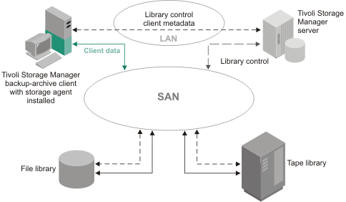

Como se muestra en la [Figura 2](http://pic.dhe.ibm.com/infocenter/tsminfo/v6r3/topic/com.ibm.itsm.sta.doc/c_overview.html#c_overview__lanfreecommmethodfig), el agente de almacenamiento puede soportar varios clientes mientras esté instalado sólo en uno de los clientes. También puede instalar el agente de almacenamiento en un sistema cliente que no comparta recursos de almacenamiento con el servidor de Tivoli Storage Manager, pero que esté conectado a un sistema cliente que sí comparta recursos de almacenamiento. La opción LANFREECOMMMETHOD permite a un sistema cliente que comparte recursos de almacenamiento comunicarse con el agente de almacenamiento. La opción LANFREECOMMMETHOD también permite al agente de almacenamiento dar soporte a varios clientes mientras el agente de almacenamiento está instalado en solo uno de los clientes.

*Figura 2. Movimiento de datos de SAN con la opción LANFREECOMMMETHOD*. *Las líneas continuas indican movimiento de datos. Las líneas discontinuas indican un movimiento de información de control y metadatos.*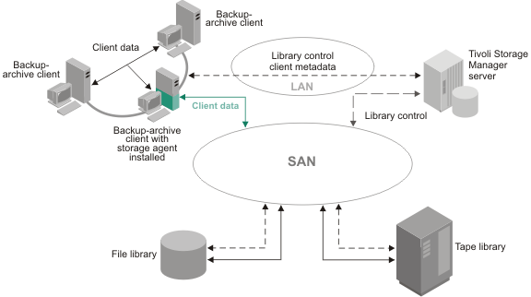

Un servidor de Tivoli Storage Manager, cuando actúa como un gestor de biblioteca, controla los dispositivos de almacenamiento. Este servidor puede ser el servidor que funciona con el agente de almacenamiento o con otro servidor de Tivoli Storage Manager de la empresa. El servidor de Tivoli Storage Manager realiza el seguimiento de los metadatos que el cliente ha almacenado. Los metadatos, por ejemplo la información de la política y el nombre y el tamaño del archivo, se pasan a través de la conexión de LAN existente entre el agente de almacenamiento y el servidor.

El agente de almacenamiento se comunica con el servidor para obtener y almacenar información de la base de datos y para coordinar el acceso a dispositivos y volúmenes. El servidor y el cliente coordinan y transfieren el acceso de datos a través de la SAN. El cliente utiliza el agente de almacenamiento para las operaciones cuando es apropiado. Por ejemplo, si hay una vía de acceso de SAN definida, el cliente (mediante el agente de almacenamiento) transfiere datos a dicha vía de acceso. Si se produce algún problema en la vía de acceso de la SAN, se produce una sustitución por anomalía y el cliente utiliza su conexión de LAN con el servidor de Tivoli Storage Manager y transfiere los datos del cliente a través de la LAN.

El agente de almacenamiento puede enviar los datos directamente al servidor mediante las vías de acceso entre el agente de almacenamiento y el servidor. Un ejemplo de ello puede ser una agrupación de almacenamiento sin LAN que se actualiza para que sea sólo de lectura después de que el cliente se haya conectado al servidor y haya obtenido la información de política inicial. El agente de almacenamiento, en lugar de rechazar la operación, enviará los datos al servidor. Si la jerarquía de almacenamiento se configura de manera que esté disponible el destino de la agrupación de almacenamiento siguiente, el servidor realizará la operación.

También puede impedir que se transfieran los datos a través de la LAN especificando los parámetros del servidor de Tivoli Storage ManagerDATAREADPATH y DATAWRITEPATH con el comando REGISTER NODE o UPDATE NODE para el nodo deseado. Para revisar estos valores, emita el mandato siguiente en el servidor para el nodo:

query node nombre\_nodo format=detailed

Tivoli Storage Manager soporta el compartimiento de dispositivos conectados a SAN en los entornos siguientes:

* Soporte de gestión de biblioteca nativa de Tivoli Storage Manager que conste de un gestor de biblioteca ACSLS, SCSI o IBM 349X y de clientes de biblioteca o sólo un gestor de biblioteca.
* Almacenamiento de disco compartido mediante una biblioteca FILE y la integración de IBM General Parallel File System, IBM Tivoli SANergy o IBM TotalStorage SAN File System. General Parallel File System es la opción preferida para los sistemas operativos en los que se soporta.
* Bibliotecas externas.
* AIX operating systemsLinux operating systemsSun Solaris operating systemsWindows operating systems [**Visión general del agente de almacenamiento y del servidor de medios de z/OS**](http://pic.dhe.ibm.com/infocenter/tsminfo/v6r3/topic/com.ibm.itsm.sta.doc/c_zsrv_sta_overview.html)  
  IBM Tivoli Storage Manager for z/OS Media permite a los sistemas cliente, a través de un agente de almacenamiento, comunicarse con dispositivos de almacenamiento conectados a un sistema z/OS.
* [**Copia de seguridad de datos de cliente sin LAN: caso de ejemplo**](http://pic.dhe.ibm.com/infocenter/tsminfo/v6r3/topic/com.ibm.itsm.sta.doc/c_scenario_lanfree.html)  
  Los soportes de cinta y de archivos que se deben utilizar para los datos de copia de seguridad de cliente que residen en una agrupación de almacenamiento que utiliza un dispositivo compartido en una SAN. Un gestor de biblioteca envía la ubicación al agente de almacenamiento. Los datos de copia de seguridad van directamente al dispositivo a través de una SAN.

Expando:

# Copia de seguridad de datos de cliente sin LAN: caso de ejemplo

Los soportes de cinta y de archivos que se deben utilizar para los datos de copia de seguridad de cliente que residen en una agrupación de almacenamiento que utiliza un dispositivo compartido en una SAN. Un gestor de biblioteca envía la ubicación al agente de almacenamiento. Los datos de copia de seguridad van directamente al dispositivo a través de una SAN.

Un caso de ejemplo típico para el movimiento de datos sin LAN consta de los pasos siguientes:

1. El cliente de archivado y copia de seguridad empieza una operación de copia de seguridad. El servidor notifica la información de políticas al cliente, que incluye si el destino es sin LAN. El cliente, mientras asigna valores de política para los archivos durante el proceso de copia de seguridad, envía los datos, mediante el movimiento de datos sin LAN, cuando el destino de esa política tiene habilitado el soporte sin LAN.

Una agrupación de almacenamiento es un destino sin LAN cuando la agrupación de almacenamiento utiliza un dispositivo compartido en una SAN. Dicho dispositivo también debe tener definida una vía de acceso al agente de almacenamiento.

1. El agente de almacenamiento recibe datos de aquellos archivos de los que el cliente ha realizado copia de seguridad y les ha asignado valores de política que utilizan una agrupación de almacenamiento habilitada sin LAN. El agente de almacenamiento envía una solicitud de montaje de volumen al servidor gestor de biblioteca. En las bibliotecas externas, el agente de almacenamiento se pone en contacto con el gestor de biblioteca externa, utilizando la vía de acceso del archivo ejecutable.
2. Se realiza una solicitud al dispositivo de almacenamiento solicitándole que monte el medio adecuado.
3. El gestor de bibliotecas notifica al agente de almacenamiento dónde residen los medios montados. En las bibliotecas externas, el gestor de biblioteca externa notifica la ubicación del dispositivo al agente de almacenamiento.
4. El cliente, a través del agente de almacenamiento, escribe los datos de copia de seguridad directamente en el dispositivo a través de la SAN.
5. El agente de almacenamiento envía información de metadatos al servidor de Tivoli Storage Manager y el servidor almacena la información en la base de datos.

**Restricción:** El movimiento de datos sin LAN tiene prioridad sobre la eliminación de datos duplicados del cliente. Si se produce un movimiento de datos sin LAN durante la eliminación de datos duplicados del cliente, esta eliminación de datos duplicados del cliente se desactiva y se anota un mensaje en el registro cronológico de errores.

**Tema principal:** [Visión general del agente de almacenamiento](http://pic.dhe.ibm.com/infocenter/tsminfo/v6r3/topic/com.ibm.itsm.sta.doc/c_overview.html)

* [**Restauración sin consulta de varias sesiones para vía de acceso sin LAN: caso de ejemplo**](http://pic.dhe.ibm.com/infocenter/tsminfo/v6r3/topic/com.ibm.itsm.sta.doc/c_scenario_no_query_restore.html)  
  Cuando se realiza una restauración sin consulta, el servidor de Tivoli Storage Manager crea una lista de los archivos que han de restaurarse y envía datos al cliente mientras sigue creando la lista. Esto permite que la restauración pueda reiniciarse si se interrumpe.

Expando:

# Restauración sin consulta de varias sesiones para vía de acceso sin LAN: caso de ejemplo

Cuando se realiza una restauración sin consulta, el servidor de Tivoli Storage Manager crea una lista de los archivos que han de restaurarse y envía datos al cliente mientras sigue creando la lista. Esto permite que la restauración pueda reiniciarse si se interrumpe.

Se utilizan varias sesiones para la restauración sin consulta cuando los datos de la restauración se encuentran en dispositivos con una vía de acceso sin LAN y en dispositivos con una vía de acceso sólo de LAN. Algunas sesiones restauran datos del servidor con una vía de acceso sólo de LAN. Las otras sesiones utilizan el agente de almacenamiento para restaurar datos a través de la vía de acceso sin LAN.

El número de sesiones utilizadas para una operación de restauración depende del valor de la opción RESOURCEUTILIZATION de cliente y del número de volúmenes de servidor que contengan los datos de cliente que se deben restaurar.

Las acciones siguientes describen una restauración sin consulta de varias sesiones típica para una vía de acceso sin LAN:

1. El cliente solicita la restauración de un espacio de archivos. Esta solicitud se reenvía al servidor.
2. El servidor determina qué archivos han de restaurarse y el volumen en el que residen esos archivos. El servidor genera una lista, ordenada por los nombres de los volúmenes.
3. El cliente recibe información acerca del progreso y del número de volúmenes. El cliente puede iniciar más sesiones para restaurar la información.
4. La ubicación del volumen, y si el agente de almacenamiento puede o no acceder al volumen, determinarán la forma en que se manejarán los datos. Cuando el volumen puede montarse en un dispositivo compartido al que el agente de almacenamiento puede acceder, el agente de almacenamiento lee los datos del volumen y los envía al cliente. Cuando el volumen no puede montarse en un dispositivo compartido al que el agente de almacenamiento puede acceder, el servidor lee los datos del volumen y los envía directamente al cliente. A continuación, el cliente inicia sesiones adicionales: algunas con el agente de almacenamiento para los volúmenes habilitados para estar sin LAN y otras con el servidor para los volúmenes que no están habilitados para estar sin LAN.

El proceso se repite hasta que se han restaurado todos los archivos de la lista.

**Tema principal:** [Visión general del agente de almacenamiento](http://pic.dhe.ibm.com/infocenter/tsminfo/v6r3/topic/com.ibm.itsm.sta.doc/c_overview.html)

* AIX operating systemsLinux operating systemsSun Solaris operating systemsWindows operating systems [**Movimiento de datos en un entorno de servidor de medios de z/OS: caso de ejemplo**](http://pic.dhe.ibm.com/infocenter/tsminfo/v6r3/topic/com.ibm.itsm.sta.doc/c_scenario_zsrv.html)  
  Un agente de almacenamiento está configurado para acceder a recursos de almacenamiento de z/OS que están controlados por un servidor de medios de z/OS. El agente de almacenamiento está instalado en un sistema cliente que se comunica con el servidor de medios de z/OS a través de la LAN.
* [**Comunicaciones entre el cliente, el agente de almacenamiento y el servidor de Tivoli Storage Manager**](http://pic.dhe.ibm.com/infocenter/tsminfo/v6r3/topic/com.ibm.itsm.sta.doc/c_communications_establish.html)  
  Las tareas de configuración enlazan el agente de almacenamiento, el cliente y el servidor de Tivoli Storage Manager.

--

**Protección de datos integral con licencia simplificada**

* [Tivoli Storage Manager Suite para Recuperación unificada](http://pic.dhe.ibm.com/infocenter/tsminfo/v6r3/topic/com.ibm.itsm.nav.doc/c_tsm_sur.html)

**Conformidad de retención de datos**

* [System Storage Archive Manager](http://pic.dhe.ibm.com/infocenter/tsminfo/v6r3/topic/com.ibm.itsm.nav.doc/c_complydataretention_ovr.html)

**Almacenamiento en sistemas z/OS**

* [Tivoli Storage Manager for z/OS Media](http://pic.dhe.ibm.com/infocenter/tsminfo/v6r3/topic/com.ibm.itsm.nav.doc/t_int_medsrv.html)

**Recuperación y copia de seguridad del sistema AIX**

* [Tivoli Storage Manager para la Recuperación y la copia de seguridad del sistema (SysBack)](http://publib.boulder.ibm.com/infocenter/tivihelp/v1r1/topic/com.ibm.itsmsbr.doc/smsbr.html)

Tivoli server manager overview

# Tivoli Storage Manager overview

IBM® Tivoli® Storage Manager is an enterprise-wide storage management application. It provides automated storage management services to workstations, personal computers, and file servers from a variety of vendors, with a variety of operating systems.

Tivoli Storage Manager includes the following components:

**Server**

**Server program**

The server program provides backup, archive, and space management services to the clients.

You can set up multiple servers in your enterprise network to balance storage, processor, and network resources.

**Administrative interface**

The administrative interface allows administrators to control and monitor server activities, define management policies for clients, and set up schedules to provide services to clients at regular intervals.

Administrative interfaces available include a command-line administrative client and a Web browser interface called the Administration Center. Tivoli Storage Manager allows you to manage and control multiple servers from a single interface that runs in a Web browser.

Windows operating systems The Tivoli Storage Manager server for Windows also includes the Tivoli Storage Manager Management Console (Tivoli Storage Manager Console), which is a Microsoft Management Console (MMC) snap-in.

**Server database and recovery log**

The Tivoli Storage Manager server uses a database to track information about server storage, clients, client data, policy, and schedules. The server uses the recovery log as a scratch pad for the database, recording information about client and server actions while the actions are being performed.

**Server storage**

The server can write data to hard disk drives, disk arrays and subsystems, stand-alone tape drives, tape libraries, and other forms of random- and sequential-access storage. The media that the server uses are grouped into storage pools.

The storage devices can be connected directly to the server, or connected via local area network (LAN) or storage area network (SAN).

**Client Nodes**

A client node can be a workstation, a personal computer, a file server, or even another Tivoli Storage Manager server. The client node hasIBM Tivoli Storage Manager client software installed and is registered with the server.

Network-attached storage (NAS) file servers can also be client nodes, but when using NDMP, they do not have Tivoli Storage Managerclient software installed.

**Backup-archive client**

The backup-archive client allows users to maintain backup versions of files, which they can restore if the original files are lost or damaged. Users can also archive files for long-term storage and retrieve the archived files when necessary. Users themselves or administrators can register workstations and file servers as client nodes with a Tivoli Storage Manager server.

The storage agent is an optional component that may also be installed on a system that is a client node. The storage agent enables LAN-free data movement for client operations and is supported on a number of operating systems.

**Network-attached storage file server (using NDMP)**

The server can use the Network Data Management Protocol (NDMP) to back up and restore file systems stored on a network-attached storage (NAS) file server. The data on the NAS file server is backed up to a tape library. No Tivoli Storage Manager software needs to be installed on the NAS file server. A NAS file server can also be backed up over the LAN to a Tivoli Storage Manager server. See [Using NDMP for operations with NAS file servers](http://pic.dhe.ibm.com/infocenter/tsminfo/v6r3/topic/com.ibm.itsm.srv.doc/r_ndmp.html#r_ndmp) for more information, including supported NAS file servers.

**Application client**

Application clients allow users to perform online backups of data for applications such as database programs. After the application program initiates a backup or restore, the application client acts as the interface to Tivoli Storage Manager. The Tivoli Storage Managerserver then applies its storage management functions to the data. The application client can perform its functions while application users are working, with minimal disruption.

The following products provide application clients for use with the Tivoli Storage Manager server:

* Tivoli Storage Manager for Databases
* Tivoli Storage Manager for Enterprise Resource Planning
* Tivoli Storage Manager for Mail

**Application programming interface (API)**

The API allows you to enhance existing applications to use the backup, archive, restore, and retrieve services that Tivoli Storage Manager provides. Tivoli Storage Manager API clients can register as client nodes with a Tivoli Storage Manager server.

**Tivoli Storage Manager for Space Management**

Tivoli Storage Manager for Space Management provides space management services for workstations on some platforms. The space management function is essentially a more automated version of archive. Tivoli Storage Manager for Space Management automatically migrates files that are less frequently used to server storage, freeing space on the workstation. The migrated files are also called space-managed files.

Users can recall space-managed files automatically simply by accessing them as they normally would from the workstation. Tivoli Storage Manager for Space Management is also known as the space manager client, or the hierarchical storage management (HSM) client.

**Windows operating systems HSM for Windows**

The Tivoli Storage Manager for HSM for Windows client provides hierarchical storage management (HSM) for Windows NTFS file systems. HSM is a data storage system that automatically moves data between high-cost and low-cost storage media.

High-speed storage devices are more expensive per byte stored than slower devices, such as optical discs and magnetic tape drives. While it would be ideal to have all data available on high-speed devices all the time, this is prohibitively expensive for many organizations. HSM is available to store data on slower devices, and then copy data to faster disk drives only when needed.

**Storage agents**

The storage agent is an optional component that may be installed on a system that is also a client node. The storage agent enables LAN-free data movement for client operations.

The storage agent is available for use with backup-archive clients and application clients on a number of operating systems. The Tivoli Storage Manager for Storage Area Networks product includes the storage agent.

For information about supported operating systems for clients, see the IBM Tivoli Storage Manager Web site at<http://www.ibm.com/support/entry/portal/Overview/Software/Tivoli/Tivoli_Storage_Manager>.

Client programs such as the backup-archive client and the HSM client (space manager) are installed on systems that are connected through a LAN and are registered as client nodes. From these client nodes, users can back up, archive, or migrate files to the server.

The following sections present key concepts and information about IBM Tivoli Storage Manager. The sections describe how Tivoli Storage Manager manages client files based on information provided in administrator-defined policies, and manages devices and media based on information provided in administrator-defined Tivoli Storage Manager storage objects.

The final section gives an overview of tasks for the administrator of the server, including options for configuring the server and how to maintain the server.

* [How client data is stored](http://pic.dhe.ibm.com/infocenter/tsminfo/v6r3/topic/com.ibm.itsm.srv.doc/c_tsmintro_client_data.html)  
  Tivoli Storage Manager policies are rules that determine how the client data is stored and managed. The rules include where the data is initially stored, how many backup versions are kept, how long archive copies are kept, and so on.
* [How the server manages storage](http://pic.dhe.ibm.com/infocenter/tsminfo/v6r3/topic/com.ibm.itsm.srv.doc/c_tsmintro_storage_manage.html)  
  Through the server, you manage the devices and media used to store client data. The server integrates the management of storage with the policies that you define for managing client data.

What’s new from 6.2 to 6.3

**What's New in Tivoli Storage Manager 6.3**

**Tivoli Storage Manager** provides a wide range of storage management capabilities from a single point of control, helping companies ride the information tidal wave.

Tivoli Storage Manager 6.3 expands on previous versions by delivering several new enhancements including:

* Doubled scalability of the Tivoli Storage Manager server, supporting up to 4 billion data objects, for the 3rd consecutive year
* Reduced time to install updates of backup/archive clients by at least 80% with automatic push
* Reduced time to create custom reports from hours to less than 30 minutes

## Version-to-Version Feature comparison

| **Features** | **V.6.1** | **V.6.2** | **V.6.2** |
| --- | --- | --- | --- |
| Server Capacity (# of Objects) | 1B | 2B | 4B |
| Target-side data deduplication | X | X | X |
| Disaster Recovery — Planning | X | X | X |
| Reporting and monitoring | X | X | X |
| Automatic client software updates — Windows |  | X | X |
| Source-side data deduplication |  | X | X |
| Unified Recovery Management — Fastback |  | X | X |
| Unified Recovery Management — Fastback and Extended Suite |  |  | X |
| Disaster Recovery — Database & Client Data Replication |  |  | X |
| Reporting and monitoring — including Cognos |  |  | X |
| Automatic client software updates — All O/S |  |  | X |

Tivli different editions

# Tivoli Storage Manager

**Compare editions**

Today’s data storage managers are being asked to work miracles: back up massive amounts of data without impacting operations, restore lost data almost instantaneously, protect different sets of data in accordance with different security and retention policies, and do it all on a shrinking budget. And the challenges don’t get easier with time.

The IBM® Tivoli® Storage Manager family of software offerings help organizations of all sizes meet these challenges, both today and for the future, with exceptional levels of functionality, scalability, performance, reliability and time-to-value. All members of the family help to reduce overall storage capacity requirements, reduce risks associated with data loss, and improve service levels.

The list below will help you choose the family edition that is right for your organization.

## Compare editions

| **Compatibility and pricing** | **for Storage Manager** | **for Extended Edition** | | **For Unified Recovery** | |
| --- | --- | --- | --- | --- | --- |
|  | [**Learn more**](http://www.ibm.com/software/tivoli/products/storage-mgr/)  [View pricing](https://www-112.ibm.com/software/howtobuy/buyingtools/paexpress/Express?P0=E1&part_number=D56FULL,D5158LL,D56FPLL,D51MYLL,D56FLLL,D56FSLL,D56Q3LL,D56D9LL,D55H5LL,D56Q5LL,D54Q1LL,&catalogLocale=en_US&Locale=en_US&country=USA&S_TACT=none&S_CMP=none) | [**Learn more**](http://www.ibm.com/software/tivoli/products/storage-mgr-extended/)  [View pricing](https://www-112.ibm.com/software/howtobuy/buyingtools/paexpress/Express?P0=E1&part_number=D56FELL,D51MKLL,D56FLLL,D51MYLL,D56FJLL,&catalogLocale=en_US&Locale=en_US&country=USA&S_TACT=none&S_CMP=none) | | [**Learn more**](http://www.ibm.com/software/tivoli/products/storage-mgr-unified/)  [View pricing](https://www-112.ibm.com/software/howtobuy/buyingtools/paexpress/Express?P0=E1&part_number=D0BM1LL,D0BM9LL,D0BMBLL,D0BMJLL,D0BMKLL,D0BMULL,D0BMVLL&catalogLocale=en_US&locale=en_US&country=USA&PT=html) | |
| **Description** | Automates data backup, restore and archive functions, centralizes storage management operations | Expands on backup, restore and archive abilities with disaster recovery functionality | | Bundle of 10 Tivoli Storage Manager products licensed on a tiered (TB) capacity model | |
| **Operating system** | Windows, HP Unix, z/OS, Linux, Sun Solaris, AIX | Windows, HP Unix, z/OS, Linux, Sun Solaris, AIX | | Windows, HP Unix, z/OS, Linux, Sun Solaris, AIX | |
| **Scalability** | Upper SMB and small enterprise | Large enterprise | | Large enterprise | |
| **Licensing** | Processor Value Unit | Processor Value Unit | | Capacity pricing | |
| **Upgrade path** | Extended |  | |  | |
| **Key features** | | **Storage Manager Manager** | **Extended Edition** | | **Unified Recovery** |
| **Tape library support - selected libraries** | | Yes | Yes | | Yes |
| **NDMP backup for NAS** | |  | Yes | | Yes |
| **Reporting and monitoring** | | Yes | Yes | | Yes |
| **Advanced tape management, efficient tape utilization** | | Yes | Yes | | Yes |
| **Disk-tape backup** | | Yes | Yes | | Yes |
| **Tiered storage management of backup and archive data** | | Yes | Yes | | Yes |
| **Archive management** | | Yes | Yes | | Yes |
| **Advanced tape library support - greater than 4 drives or 48 tape slots** | |  | Yes | | Yes |
| **Disaster Recovery Manager, disaster recovery planning** | |  | Yes | | Yes |
| **Asynchronous replication for ‘warm standby’ Disaster Recovery** | |  | Yes | | Yes |
| **Extensive policy management and granular control** | | Yes | Yes | | Yes |
| **Data de-duplication** | | Yes | Yes | | Yes |
| **Disk-disk, disk-disk-tape backup** | | Yes | Yes | | Yes |
| **Backup and recovery management** | | Yes | Yes | | Yes |
| **Automatic push of client updates** | | Yes | Yes | | Yes |
| **Advanced backup and flexible recovery for VMware** | | O | O | | Yes |
| **Non-disruptive backup for Oracle and Microsoft SQL data** | | O | O | | Yes |
| **Protects vital SAP R/3 system data more efficiently, consistently and reliably** | | O | O | | Yes |
| **Protects Lotus Domino and Microsoft Exchange data** | | O | O | | Yes |
| **Granular e-mail object restore for Microsoft Exchange** | | O | O | | Yes |
| **Block-level backup and near-instant restore of Windows and Linux** | | O | O | | Yes |
| **Bare Machine Recovery of Windows and Linux servers** | | O | O | | Yes |
| **Automatic migration of inactive data to reclaim online disk space** | | O | O | | Yes |
| **LAN-Free backup and restore** | | O | O | | Yes |

<http://www-01.ibm.com/software/tivoli/products/storage-mgr/productline/compare.html>

**Overview**

IBM Tivoli Storage Manager protects data from hardware failures, errors, and unforeseen

disasters by storing backup and archive copies on offline and off-site storage. Scaling to

protect hundreds to thousands of computers running more than a dozen operating systems,

ranging from mobile computers to mainframes and connected together by the Internet,

WANs, LANs, or SANs, Storage Manager Extended Edition's centralized Web-based

management, intelligent data move and store techniques, and comprehensive policy-based

automation all work together to minimize administration costs and the impact to both

computers and networks.

Optional software modules allow business-critical applications that must run 24x365 to utilize

Storage Manager's centralized data protection with no interruption to their service. Optional

software extensions also allow SAN-connected computers to use the SAN for data protection

data movements, and provide Hierarchical Storage Management to automatically move

unused data files from online disk storage to offline tape storage. Storage Manager Extended

Edition expands on the data backup and restore and managed data archive and retrieve

capabilities of the base Storage Manager by adding disaster planning capability, NDMP

control for NAS filers, and support for large tape libraries.

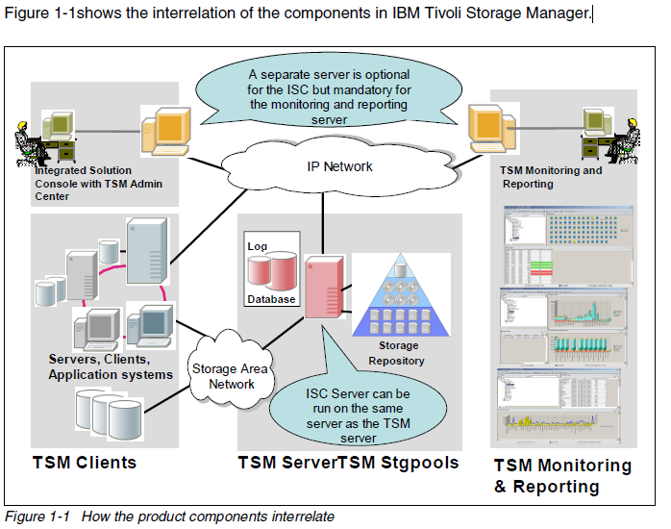

**IBM Tivoli Storage Manager Servers Version 6.1**

New features and enhancements are available in the Tivoli Storage Manager Version 6.1

server and related products. Here we summarize these features and enhancements in short,

high-level descriptions, so that you can start thinking about the potential benefits to your

storage-management operations. The changes introduced in Version 6.1.0 onwards are:

\_ Changes to the Version 6.1 Administration Center:

Many features in the Tivoli Storage Manager Administration Center Version 6.1 are new

for previous users.

\_ Data deduplication:

Data deduplication is a method of eliminating redundant data in sequential-access disk

(FILE) primary, copy, and active-data storage pools. One unique instance of the data is

retained on storage media, and redundant data is replaced with a pointer to the unique

data copy. The goal of deduplication is to reduce the overall amount of time that is

required to retrieve data by letting you store more data on disk, rather than on tape.

\_ Storage devices:

New device support and other changes to storage devices are available in Tivoli Storage

Manager Version 6.1.

\_ Disaster recovery manager support for active-data pools:

To restore your client systems more quickly and efficiently, you can now use active-data

pools in your recovery plans and procedures.

\_ EXPIRE INVENTORY command enhancements:

The EXPIRE INVENTORY command is now enhanced with new functionality.

\_ No-query restore changes:

The no-query restore (NQR) function and the internal algorithms responsible for NQR

were changed to take advantage of DB2 capabilities and to improve performance.

\_ Server database:

Tivoli Storage Manager version 6.1 provides a new server database. Advantages include

automatic statistics collection and database reorganization, full-function SQL queries, and

elimination of the need for offline audits of the database.

\_ Support for NetApp SnapMirror® to Tape feature:

With Tivoli Storage Manager you can create SnapMirror to Tape images of file systems on

NetApp file servers.

\_ ODBC driver support:

Tivoli Storage Manager Version 6.1 uses the DB2 open database connectivity (ODBC)

driver to query the database and display the results.

\_ Reporting and monitoring feature:

The reporting and monitoring feature uses a combination of the Tivoli Common Reporting

tool, IBM Tivoli Monitoring, and the IBM Tivoli Data Warehouse to offer you reports and

real time monitoring information about Tivoli Storage Manager servers and client activity

**1.5.1 Tivoli Storage Manager for SAN, additions, and changes**

IBM Tivoli Storage Manager for Storage Area Networks is a feature of Tivoli Storage Manager

that enables LAN-free client data movement.

This feature allows the client system to directly write data to, or read data from, storage

devices attached to a storage area network (SAN), instead of passing or receiving the

information over the network. Data movement is thereby off-loaded from the LAN and from

the Tivoli Storage Manager server, making network bandwidth available for other uses. For

instance, using the SAN for client data movement decreases the load on the Tivoli Storage

Manager server and allows it to support a greater number of concurrent client connections.

The storage agent, a component of the feature, makes LAN-free data movement possible.

<http://www.redbooks.ibm.com/redbooks/pdfs/sg247718.pdf>

Tivoli Storage area networks

<http://www-01.ibm.com/software/tivoli/products/storage-mgr-san/>

## verview

### Learn more

* [System requirements](http://www.ibm.com/support/docview.wss?uid=swg21243309&S_CMP=rnav)
* [Product library](https://www-927.ibm.com/search/SearchLibrary?max_records=10&search_library=true&text=*&search.x=0&search.y=0&prodcat=all&brand=all&solution=all&os=all&date=all&prdkey=X258329T36575U56&S_CMP=rnav)

### Use and maintain

* [Product support](http://www-01.ibm.com/software/sysmgmt/products/support/IBMTivoliStorageManagerforStorageAreaNetworks.html?S_CMP=rnav)
* [Product documentation](http://publib.boulder.ibm.com/infocenter/tsminfo/v6/index.jsp)
* [Developer resources](http://www.ibm.com/developerworks/tivoli/)
* [User groups](http://www-01.ibm.com/software/sysmgmt/products/support/Tivoli_User_Groups.html)

**IBM Tivoli® Storage Manager for Storage Area Networks works with servers and client computers to make data transfers over SAN**

Allows SAN-connected Storage Manager servers and Storage Manager client computers to make maximum use of their direct network connection to storage.

* Reduces the impact of data protection on the LAN while also reducing CPU utilization on both client and server
* LAN-free backup/restore that removes data transfer from the LAN, providing high-performance backup/restore and minimizing network traffic, improving application performance and transaction response times on the TSM server
* Supports a SAN-connected tape library, where multiple servers can share a tape library and tape drives on a Storage Area Network
* Operating systems supported: AIX, HP-UX, Linux, Solaris (Sun microsystems), Windows family, z/OS

# IBM Tivoli Storage Manager for Windows: Administrator's Guide

## [Selecting a Device Configuration](http://www.urz.uni-heidelberg.de/ADSM/ibmdoc.tsm52/win/html/guide/anrwgd5102.htm#ToC_78)

The following sections describe ways that you can configure your storage devices to work with Tivoli Storage Manager:

* [Devices on a Local Area Network](http://www.urz.uni-heidelberg.de/ADSM/ibmdoc.tsm52/win/html/guide/anrwgd5128.htm#HDRCONCFG)
* [Devices on a Storage Area Network](http://www.urz.uni-heidelberg.de/ADSM/ibmdoc.tsm52/win/html/guide/anrwgd5128.htm#HDRSANSHR)
* [LAN-Free Data Movement](http://www.urz.uni-heidelberg.de/ADSM/ibmdoc.tsm52/win/html/guide/anrwgd5128.htm#HDRLFREE)
* [Network-Attached Storage](http://www.urz.uni-heidelberg.de/ADSM/ibmdoc.tsm52/win/html/guide/anrwgd5128.htm#HDRNASOVW)
* [Server-Free Data Movement](http://www.urz.uni-heidelberg.de/ADSM/ibmdoc.tsm52/win/html/guide/anrwgd5128.htm#HDRSVDMCON)

For information about supported devices and Fibre Channel hardware and configurations, see the following Web site at this address [www.ibm.com/software/sysmgmt/products/   
support/IBMTivoliStorageManager.html](http://www.ibm.com/software/sysmgmt/products/support/IBMTivoliStorageManager.html)

### |[Devices on a Local Area Network](http://www.urz.uni-heidelberg.de/ADSM/ibmdoc.tsm52/win/html/guide/anrwgd5102.htm#ToC_79)

In the conventional local area network (LAN) configuration, one or more tape or optical libraries are associated with a single Tivoli Storage Manager server. In a LAN configuration, client data, electronic mail, terminal connection, application program, and device control information must all be handled by the same network. Device control information and client backup and restore data flow across the LAN.

For information on the categories of libraries supported by Tivoli Storage Manager, see [Libraries](http://www.urz.uni-heidelberg.de/ADSM/ibmdoc.tsm52/win/html/guide/anrwgd5125.htm#HDRDEVLIB).

### |[Devices on a Storage Area Network](http://www.urz.uni-heidelberg.de/ADSM/ibmdoc.tsm52/win/html/guide/anrwgd5102.htm#ToC_80)

A storage area network (SAN) is a dedicated storage network that can improve system performance. On a SAN you can consolidate storage and relieve the distance, scalability, and bandwidth limitations of LANs and wide area networks (WANs). Using Tivoli Storage Manager in a SAN allows the following functions:

* Sharing storage devices among multiple Tivoli Storage Manager servers. For more information on sharing storage devices, see [Configuring Tivoli Storage Manager Servers to Share SAN-Connected Devices](http://www.urz.uni-heidelberg.de/ADSM/ibmdoc.tsm52/win/html/guide/anrwgd5151.htm#HDRSHARLIBX).
* Allowing Tivoli Storage Manager clients, through a storage agent on the client machine, to move data directly to storage devices (LAN-free data movement).
* Allowing an outboard data mover to move client data to storage devices (server-free data movement).

In a SAN you can share storage devices that are supported by the Tivoli Storage Manager device driver. This includes most SCSI devices, but does not include devices that use the GENERICTAPE device type. See[Chapter 4, Attaching Devices to the Server System](http://www.urz.uni-heidelberg.de/ADSM/ibmdoc.tsm52/win/html/guide/anrwgd5139.htm#HDRATTDEV) for device driver setup information.

[Figure 5](http://www.urz.uni-heidelberg.de/ADSM/ibmdoc.tsm52/win/html/guide/anrwgd5128.htm#FIGSANFIG) shows a SAN configuration in which two Tivoli Storage Manager servers share a library.

**Figure 5. Library Sharing in a Storage Area Network (SAN) Configuration**. The servers communicate over the LAN. The library manager controls the library over the SAN. The library client stores data to the library devices over the SAN.

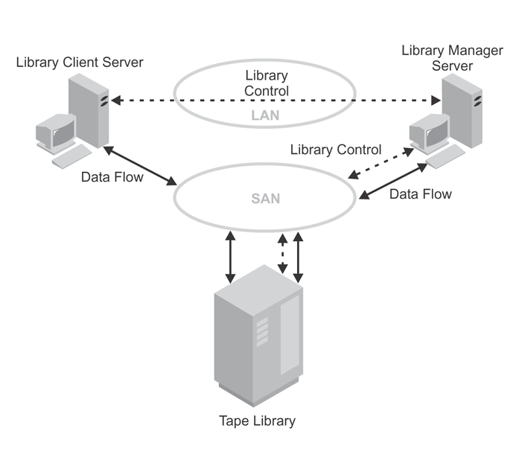

When Tivoli Storage Manager servers share a library, one server, the *library manager*, controls device operations. These operations include mount, dismount, volume ownership, and library inventory. Other Tivoli Storage Manager servers, *library clients*, use server-to-server communications to contact the library manager and request device service. Data moves over the SAN between each server and the storage device.

Tivoli Storage Manager servers use the following features when sharing an automated library:

**Partitioning of the Volume Inventory**

The inventory of media volumes in the shared library is partitioned among servers. Either one server owns a particular volume, or the volume is in the global scratch pool. No server owns the scratch pool at any given time.

**Serialized Drive Access**

Only one server accesses each tape drive at a time. Drive access is serialized and controlled so that servers do not dismount other servers' volumes or write to drives where other servers mount their volumes.

**Serialized Mount Access**

The library autochanger performs a single mount or dismount operation at a time. A single server (library manager) performs all mount operations to provide this serialization.

### [LAN-Free Data Movement](http://www.urz.uni-heidelberg.de/ADSM/ibmdoc.tsm52/win/html/guide/anrwgd5102.htm#ToC_81)

|Tivoli Storage Manager allows a client, through a storage agent, to |directly back up and restore data to a tape library on a SAN. [Figure 6](http://www.urz.uni-heidelberg.de/ADSM/ibmdoc.tsm52/win/html/guide/anrwgd5128.htm#FIGLANFREEFIG) shows a SAN configuration in which a client directly |accesses a tape or FILE library to read or write data.

**Figure 6. LAN-Free Data Movement**. Client and server communicate over the LAN. The server controls the device on the SAN. Client data moves over the SAN to the device.

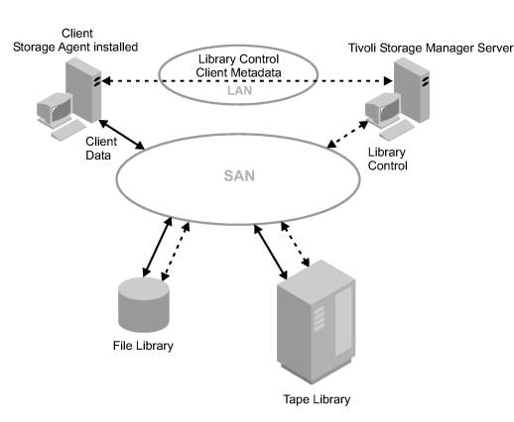

LAN-free data movement requires the installation of a storage agent on the client machine. The server maintains the database and recovery log, and acts as the library manager to control device operations. The storage agent on the client handles the data transfer to the device on the SAN. This implementation frees up bandwidth on the LAN that would otherwise be used for client data movement.

The following outlines a typical backup scenario for a client that uses LAN-free data movement:

1. The client begins a backup operation. The client and the server exchange policy information over the LAN to determine the destination of the backed up data.

For a client using LAN-free data movement, the destination is a storage pool that uses a device on the SAN.

1. Because the destination is on the SAN, the client contacts the storage agent, which will handle the data transfer. The storage agent sends a request for a volume mount to the server.
2. The server contacts the storage device and, in the case of a tape library, mounts the appropriate media.
3. The server notifies the client of the location of the mounted media.
4. The client, through the storage agent, writes the backup data directly to the device over the SAN.
5. The storage agent sends file attribute information to the server, and the server stores the information in its database.

If a failure occurs on the SAN path, failover occurs. The client uses its LAN connection to the Tivoli Storage Manager server and moves the client data over the LAN.

**Note:**

See the IBM Tivoli Storage Manager home page at [www.ibm.com/software/sysmgmt/products/   
support/IBMTivoliStorageManager.html](http://www.ibm.com/software/tivoli/solutions/storage/) for the latest information on clients that support the feature.

### [Network-Attached Storage](http://www.urz.uni-heidelberg.de/ADSM/ibmdoc.tsm52/win/html/guide/anrwgd5102.htm#ToC_82)

|Network-attached storage (NAS) file servers are dedicated storage |machines whose operating systems are optimized for file-serving |functions. NAS file servers typically do not run third-party |software. Instead, they interact with programs like Tivoli Storage |Manager through industry-standard network protocols, such as NDMP. |Tivoli Storage Manager uses the NDMP protocol to communicate with and direct |backup and restore operations for NAS file servers.

Using NDMP, Tivoli Storage Manager can back up and restore images of complete file systems. NDMP allows the Tivoli Storage Manager server to control the backup of a NAS file server. The file server transfers the backup data to a drive in a SCSI-attached tape library. The NAS file server can be distant from the Tivoli Storage Manager server.

Tivoli Storage Manager tracks file system image backups on tape, and has the capability to perform NDMP file-level restores. For more information regarding NDMP file-level restores, see [NDMP File-Level Restore](http://www.urz.uni-heidelberg.de/ADSM/ibmdoc.tsm52/win/html/guide/anrwgd5128.htm#HDRFLEVELREST).

**Figure 7. Network- Attached Storage (NAS) Configuration**

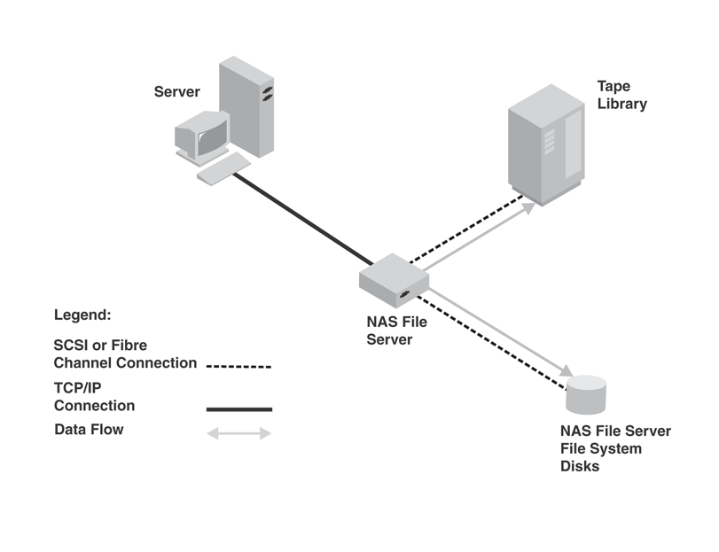

#### |Tivoli Storage Manager and Other NAS Backup Methods

When Tivoli Storage Manager uses NDMP to protect NAS file servers, the Tivoli Storage Manager server controls operations while the NAS file server transfers the data. To use a backup-archive client to back up a NAS file server, mount the NAS file server file system on the client machine (with either an NFS mount or a CIFS map) and back up as usual. The following table compares the two methods:

**Table 4. Comparing NDMP Operations and Tivoli Storage Manager Backup-Archive Client Operations**

|  |  |
| --- | --- |
| **NDMP** | **Tivoli Storage Manager Backup-Archive Client** |
| Network data traffic is less because the Tivoli Storage Manager server controls operations remotely, but the NAS file server moves the data locally. | Network data traffic is greater because all backup data goes across the LAN from the NAS file server to the client and then to the Tivoli Storage Manager server. |
| Less file server processing is required to back up a file system because the backup does not use file access protocols such as NFS and CIFS. | More file server processing is required because file backups require additional overhead for file access protocols such as NFS and CIFS. |
| The Tivoli Storage Manager server can be distant from the NAS file server and the tape library. | The Tivoli Storage Manager server must be within SCSI or Fibre Channel range of the tape library. |

#### NDMP Backup Operations

In backup images produced by NDMP operations for a NAS file server, Tivoli Storage Manager creates NAS file system image backups. The image backups are different from traditional Tivoli Storage Manager backups because the NAS file server transfers the data to the drives in the library. NAS file system image backups can be either full or differential image backups. The first backup of a file system on a NAS file server is always a full image backup. By default, subsequent backups are differential image backups containing only data that has changed in the file system since the last full image backup. If a full image backup does not already exist, a full image backup is performed.

If you restore a differential image, Tivoli Storage Manager automatically restores the full backup image first, followed by the differential image.

The following operations are not supported for data that has been backed up by using NDMP:

* Storage pool migration
* Storage pool backup and restore
* Reclamation
* Move data operations
* Export and import operations
* Backup set generation

#### |NDMP File-Level Restore

|Tivoli Storage Manager provides an option whereby file-level restores can |be performed based on backup images produced by NDMP operations. Your |choices can be summarized as follows:|

* |If you enable the file-level restore option, the Tivoli Storage Manager |server collects and stores file level information when backing up file system |images by using NDMP operations. This requires additional processing |and network resources. However, you will be able to use the Web client |to query and present file-level information to a user who can then select |files and directories to restore.
* |If you do not enable the file-level restore option, the Tivoli Storage |Manager server backs up file system images by using NDMP operations without |gathering file-level information. You will not be able to list the|files on the client. You will be able to restore them if you already |know what they are. This is the default setting.|

|If you choose to enable the file-level restore option, the Tivoli Storage |Manager server constructs a table of contents (TOC) of file-level information |for a single backup image produced by NDMP operations. The TOC is|stored in the server storage of the Tivoli Storage Manager server. The |server can then retrieve the TOC so that information can be queried by the |client or server.

|The TOC is created when backing up using backup images produced by NDMP |operations using the:|

* |BACKUP NAS client command, with *include.fs.nas* |specified in the client options file or specified in the client options set
* |BACKUP NODE server command|

### [Server-Free Data Movement](http://www.urz.uni-heidelberg.de/ADSM/ibmdoc.tsm52/win/html/guide/anrwgd5102.htm#ToC_86)

Tivoli Storage Manager allows clients to directly back up and restore file system images between disk storage and tape devices accessible over a SAN. This server-free data movement is handled on behalf of the Tivoli Storage Manager server by an outboard data mover, such as the IBM SAN Data Gateway. The data mover must be able to execute the SCSI-3 extended copy command. Server-free data movers must have addressability to all the devices involved, which include disk and tape drives. The devices may be attached to the SAN through either direct Fibre-Attach or SCSI devices connected to a data mover.

Unlike traditional LAN and LAN-free backups and restores, data passes through neither the client nor the server. Instead, the data mover handles the data. In this way, backup and restore operations do not require resources from client or server processors or from the LAN. Because it will not be copying data, the Tivoli Storage Manager server can handle more concurrent client connections and server operations. In addition, the Tivoli Storage Manager client machine, not having to read and send data to the server, can handle a greater application load.

[Figure 8](http://www.urz.uni-heidelberg.de/ADSM/ibmdoc.tsm52/win/html/guide/anrwgd5128.htm#FIGSRVFRDM) shows the movement of server-free data. The numbers (such as **(1)**) refer to numbers in the figure.

**Figure 8. Server-Free Data Movement**  
  
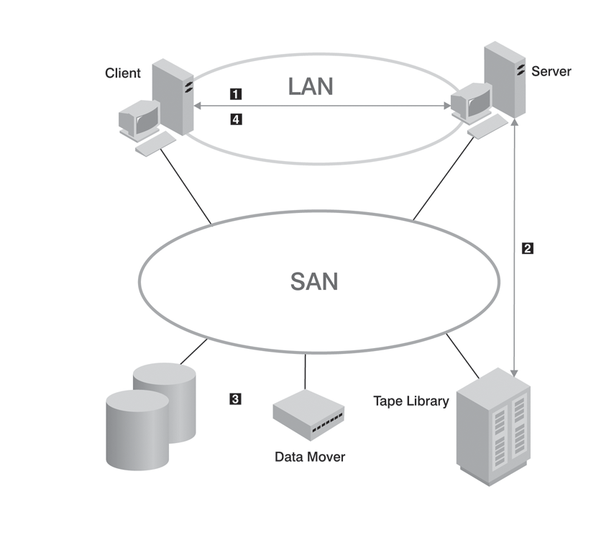

1. The client initiates a backup or restore image request (**(1)**).
2. The Tivoli Storage Manager server issues a mount request to the library (**(2)**).
3. The data mover initiates a copy operation (**(3)**).
4. The data is copied between the disk and the tape library (**(4)**).

Server-free operations transfer only volume images, not standard, file-level data. Images backed up by server-free data movement must be stored in storage pools with a data format of NONBLOCK. If the client cannot perform a server-free backup or restore, the operation fails over first to a LAN-free operation. If that operation cannot be performed, the client attempts a LAN-based backup or restore.

Server-free operations can restore LAN-based or LAN-free volume image backups. [Table 5](http://www.urz.uni-heidelberg.de/ADSM/ibmdoc.tsm52/win/html/guide/anrwgd5128.htm#TBLFLOVR) describes the possible combinations.

**Table 5. Data Format Support**

|  |  |  |  |  |
| --- | --- | --- | --- | --- |
| **Data Format** | **LAN-Based Backup LAN-Free Backup** | **Server-Free Backup** | **LAN--Based Restore LAN-Free Restore** | **Server-Free Restore** |
| NATIVE | Yes | No | Yes | No |
| NONBLOCK | Yes | Yes | Yes | Yes |

The Tivoli Storage Manager for Windows 2000 client can perform a server-free image backup of both raw volumes and volumes that contain the NTFS file system. Tivoli Storage Manager allows users to perform full-volume backups of online volumes. The volume image version matches the volume at the start of the backup. Depending on the value of the IMAGEGAPSIZE client option, either all or only the used blocks of an NTFS volume are backed up.

The Tivoli Storage Manager client allows server-free backup and restore of volume images between different volume layouts with the exception of software-based RAID-5 volumes and software-striped volumes. When restoring to a software-based mirror volume (RAID-1), Tivoli Storage Manager restores to the primary copy only and uses the operating system to resynchronize the stale mirrors. The client supports volume layouts such as striped and mirrored only on Windows 2000 dynamic disks.

**Note:**

These restrictions apply only to software-based RAID levels, and not to storage subsystems that come with hardware RAID controllers.

Tivoli Storage Manager monitors the SAN addresses of devices it knows about. If the address of a defined devices changes due to an event on the SAN, the new address will be discovered and updated.

# FAQ: Serverless backup

**Chris Poelker, W. Curtis Preston**

* [E-mail](http://searchdatabackup.techtarget.com/tip/FAQ-Serverless-backup)
* [Print](http://searchdatabackup.techtarget.com/tip/FAQ-Serverless-backup?vgnextfmt=print)
* [A](http://searchdatabackup.techtarget.com/tip/FAQ-Serverless-backup)
* [AA](http://searchdatabackup.techtarget.com/tip/FAQ-Serverless-backup)
* [AAA](http://searchdatabackup.techtarget.com/tip/FAQ-Serverless-backup)
* [LinkedIn](http://searchdatabackup.techtarget.com/tip/FAQ-Serverless-backup)
* [Facebook](http://searchdatabackup.techtarget.com/tip/FAQ-Serverless-backup)
* [Twitter](http://searchdatabackup.techtarget.com/tip/FAQ-Serverless-backup)
* [Share This](http://searchdatabackup.techtarget.com/tip/FAQ-Serverless-backup)
* [Reprints](http://reprints.ygsgroup.com/m/techtarget)

*Editor's note: SearchStorage.com*[*experts*](http://searchstorage.techtarget.com/ateExperts/0,289622,sid5,00.html)*receives many questions from its members on the subject of serverless backup. The three questions (and answers) below will tell you what serverless backup is, what the difference is between*[*LAN-free backups and serverless backups,*](http://searchstorage.techtarget.com/tip/1,289483,sid5_gci809457,00.html)*and what the best way is to design a server-free backup architecture.*

***Do you recommend using serverless backup?***

First, let's define a few terms. LAN-free backup refers to multiple backup servers sharing tape drives. Their backups go across the [SAN](http://searchstorage.techtarget.com/originalContent/0,289142,sid5_gci952429,00.html), not the LAN.

In client-free [backup,](http://searchstorage.techtarget.com/featuredTopic/0,290042,sid5_gci941338,00.html) I split off an additional mirror (or make a snapshot) that becomes visible to a server other than the server that originally used the data (usually the backup server). Then I back up that server via that other server. The data travels from disk, through the backup server, to tape and does not travel through the client. Thus, the term client-free.

Server-free backup: Same split [mirror/snapshot](http://searchstorage.techtarget.com/tip/1,289483,sid5_gci940243,00.html) as above but the data is sent *directly* from tape to disk and doesn't go through another server of any kind. Examples include the [SCSI](http://searchstorage.techtarget.com/tip/1,289483,sid5_gci935636,00.html)extended copy (XCOPY) command that can send data through the SAN from disk to tape, without going through a server or [NDMP](http://storagemagazine.techtarget.com/strgFeature/1,291266,sid35_gci837104,00.html) that can send data directly from the NAS filer to its tape drives without going through another server.

True serverless backup can help companies do things that are simply not possible any other way. But it does add a significant level of complexity and cost though, so you need to exhaust your other choices before going down that road. Make sure you've tried LAN-free backup and client-free backup first.

[W. Curtis Preston](http://searchstorage.techtarget.com/ateAnswers/0,289620,sid5_tax286189,00.html)

***What is the difference between LAN-free backup and serverless backup?***

LAN-free backup usually involves the ability to share a SAN connected tape library between all the nodes connected in the SAN. The backup server simply coordinates access to the tape resources. Each server in the SAN actually runs a copy of the backup engine and moves its own data to tape. This is sometimes called the "SSO" or shared storage option from some backup vendors. The backup server becomes the traffic cop for the SAN connected tape resources and allows each server in the SAN to back up its own data. This removes the need to "PULL" data over the LAN via backup agents to a backup server connected tape resource.

Serverless backup is accomplished by the backup server having the ability to connect to storage on behalf of other hosts connected to the SAN and back up that host's storage on its behalf. This usually involves the use of snapshot or image copies of the production LUNs in the SAN. The snapshot is used as the source media for backup so that the production application can continue during backup. The snapshot is given access through LUN security in the SAN for access by the backup server,and the backup server sends the data to tape.

Another method is to use the SCSI extended copy command called E-Copy which allows even the backup server to get out of the backup path. E-copy allows data to move directly from disk to tape via a "data router" which provides the E-copy intelligence.

[Chris Poelker](http://searchstorage.techtarget.com/infoCenter/askTheExpertsTopics/0,294286,sid5_tax294583,00.html)

***I'm planning on implementing a SAN with two or more servers (W2K3 clustered) and using a serverless backup (tape library) architecture. What would be the best way to design this? What hardware would be needed?***

In my book *Storage Area Networks for Dummies,* there is a chapter with diagrams on simple backup solutions using FC-AL hubs and shared tape drives. You don't need expensive software for a simple solution like this either. You can simply alternate access between the cluster nodes for backup, using the integrated Windows backup utility.

Since you are going to be using a cluster, you will require shared disk for the application resources (this can be a simple shelf of FC-AL based drives through a hub) and an HBA in each server for disk and another for tape (connected to another hub).

This should not run you more than a few grand to implement. Remember: When using hubs, always keep the disk traffic separate from the tape traffic by using dedicated loops for each.

[Chris Poelker](http://searchstorage.techtarget.com/infoCenter/askTheExpertsTopics/0,294286,sid5_tax294583,00.html)

For more information:

Tip: [Do you want server-free or LAN-free backup?](http://searchstorage.techtarget.com/tip/Do-you-want-server-free-or-LAN-free-backup)  
Tip: [Serverless backup is great but adds a level of complexity](http://searchdatabackup.techtarget.com/answer/Serverless-backup-is-great-but-adds-a-level-of-complexity)   
Tip: [Do the server-free two-step](http://searchstorage.techtarget.com/tip/Do-the-server-free-two-step)

<http://www-01.ibm.com/software/tivoli/products/storage-mgr/>

# Do you want server-free or LAN-free backup?

**Rick Cook**

* [E-mail](http://searchstorage.techtarget.com/tip/Do-you-want-server-free-or-LAN-free-backup)
* [Print](http://searchstorage.techtarget.com/tip/Do-you-want-server-free-or-LAN-free-backup?vgnextfmt=print)
* [A](http://searchstorage.techtarget.com/tip/Do-you-want-server-free-or-LAN-free-backup)
* [AA](http://searchstorage.techtarget.com/tip/Do-you-want-server-free-or-LAN-free-backup)
* [AAA](http://searchstorage.techtarget.com/tip/Do-you-want-server-free-or-LAN-free-backup)
* [LinkedIn](http://searchstorage.techtarget.com/tip/Do-you-want-server-free-or-LAN-free-backup)
* [Facebook](http://searchstorage.techtarget.com/tip/Do-you-want-server-free-or-LAN-free-backup)
* [Twitter](http://searchstorage.techtarget.com/tip/Do-you-want-server-free-or-LAN-free-backup)
* [Share This](http://searchstorage.techtarget.com/tip/Do-you-want-server-free-or-LAN-free-backup)
* [Reprints](http://reprints.ygsgroup.com/m/techtarget)

Even though the terms have been commonly used for several years, there is still some confusion between LAN-free and server-free backup. In part this is because server-free backup is seen as a 'hotter' technology that promises better performance, so vendors want to refer to their approach as 'server-free' backup.

Both approaches use high-speed connections, such as Fibre Channel, and both can significantly improve the performance of tape backups when compared to conventional backup approaches. LAN-free backup connects the tape backup subsystem to the disk subsystem by a direct connection such as Fibre Channel Arbitrated Loop. This high-speed connection can transfer data at much greater than LAN speeds. LAN-free backup is usually the less expensive approach, especially when existing hardware such as tape drives can be reused.

In server-less backup a separate device takes over the job of transferring the data from the disks to the tape over the high-speed link. In effect it adds a controller, such as a Fibre Channel router or a blade in a Fibre Channel switch, to the LAN-free backup system to handle the job of moving data. The server simply acts as an overall coordinator rather than issuing the commands to move the blocks or files itself. Server-less backup provides a performance improvement over LAN-free backup, but the incremental improvement is less than what is gained by going from conventional to LAN-free backup. Server-less backup is also more expensive and complex than LAN-free backup, although this can be mitigated by using a lower performance server, or even eliminating the tape server altogether by moving its remaining functions onto another server.

The big advantage of server-less backup over LAN-free backup is that the appliances (called 'data movers' generically) that handle the control function can stream data to multiple tape drives to increase backup speed greatly in large or complex installations.

ATTO Technology Inc has [a white paper](http://www.attotech.com/pdfs/LANFree.PDF) that discusses LAN-free and Server-free backup.

[Crossroads Systems Inc.](http://www.crossroads.com/) has a white paper "Titled Server-Free Backup: Under The Covers" which explains the functions of file system management involved in backup.

*Rick Cook has been writing about mass storage since the days when the term meant an 80K floppy disk. The computers he learned on used ferrite cores and magnetic drums. For the last twenty years he has been a freelance writer specializing in storage and other computer issues.*

# LAN-free backup vs. server-free backup in a SAN: Part 2

**John Merryman**Published: 11 Mar 2002

* [E-mail](http://searchstorage.techtarget.com/news/809468/LAN-free-backup-vs-server-free-backup-in-a-SAN-Part-2)
* [Print](http://searchstorage.techtarget.com/news/809468/LAN-free-backup-vs-server-free-backup-in-a-SAN-Part-2?vgnextfmt=print)
* [A](http://searchstorage.techtarget.com/news/809468/LAN-free-backup-vs-server-free-backup-in-a-SAN-Part-2)
* [AA](http://searchstorage.techtarget.com/news/809468/LAN-free-backup-vs-server-free-backup-in-a-SAN-Part-2)
* [AAA](http://searchstorage.techtarget.com/news/809468/LAN-free-backup-vs-server-free-backup-in-a-SAN-Part-2)
* [LinkedIn](http://searchstorage.techtarget.com/news/809468/LAN-free-backup-vs-server-free-backup-in-a-SAN-Part-2)
* [Facebook](http://searchstorage.techtarget.com/news/809468/LAN-free-backup-vs-server-free-backup-in-a-SAN-Part-2)
* [Twitter](http://searchstorage.techtarget.com/news/809468/LAN-free-backup-vs-server-free-backup-in-a-SAN-Part-2)
* [Share This](http://searchstorage.techtarget.com/news/809468/LAN-free-backup-vs-server-free-backup-in-a-SAN-Part-2)
* [Reprints](http://reprints.ygsgroup.com/m/techtarget)

|  |  |  |  |  |
| --- | --- | --- | --- | --- |
|  | |  |  |  | | --- | --- | --- | | |  | | --- | | **Table of Contents** | | 1. [Introduction](http://www.searchstorage.com/tip/1,289483,sid5_gci809457,00.html) **2.**[**Industry standards review**](http://www.searchstorage.com/originalContent/0,289142,sid5_gci809468,00.html) 3. [Architectural considerations](http://www.searchstorage.com/originalContent/0,289142,sid5_gci809507,00.html) 4. [Server-free implementation considerations](http://www.searchstorage.com/originalContent/0,289142,sid5_gci809533,00.html) 5. [Conclusion](http://www.searchstorage.com/originalContent/0,289142,sid5_gci809558,00.html) | | |

**Industry standards review:**  
First it is important to distinguish between the standards behind LAN-free and server-free technologies. LAN-free utilizes Fiber Channel standards, which were formalized by the ANSI T11 technical committee in 1994. [[Reference 10](http://www.searchstorage.com/originalContent/0,289142,sid5_gci809577,00.html)] Since then, device manufacturers and software vendors have widely adopted the protocol standards. Today, disk subsystems, tape libraries, tape drives, directors, switches, routers, hubs, and host bus adapters widely support these standards.

Server-free technology currently utilizes "Third-Party Copy (3PC) which is a SNIA standard, or Extended Copy, which is a *proposed* ANSI-standard SCSI-3 command. It is critical to distinguish between the two, because Third Party Copy is the SNIA standard, which is used in implementations such as EMC Timefinder or IBM ESS Flashcopy, where logical units of disk are copied within like subsystems, or across SAN channels to like subsystems. No 'data mover' hardware components are required.

"The Extended Copy standard, the foundation of server-free backup implementations, will allow block level data to be moved directly between SAN storage devices, via specialized devices, such as 'data-mover' SAN devices. [[Reference 3](http://www.searchstorage.com/originalContent/0,289142,sid5_gci809577,00.html)] The Extended Copy proposal currently before the ANSI T10 (SCSI) Committee is part of a major revision of the SCSI specification. It contains some significant modifications from the original 3PC proposal. As of the writing of this white paper, the ANSI specification had not yet passed final balloting, although it is expected to pass and become part of the SCSI-3 standard command set." [[Reference 3](http://www.searchstorage.com/originalContent/0,289142,sid5_gci809577,00.html)]

Among other initiatives, the SNIA Backup Work Group is currently working on Extended Copy Test Plan, Extended Copy Session Management and mapping. These projects will relate directly to making Extended Copy implementations manageable, scalable, and available for open systems platforms. All of these will be integral to guiding the industry adoption and exploitation of the upcoming Extended Copy T10 Standard. [[Reference 7](http://www.searchstorage.com/originalContent/0,289142,sid5_gci809577,00.html)]

# LAN-free backup vs. server-free backup in a SAN: Part 3

**John Merryman**Published: 11 Mar 2002

* [E-mail](http://searchstorage.techtarget.com/news/809507/LAN-free-backup-vs-server-free-backup-in-a-SAN-Part-3)
* [Print](http://searchstorage.techtarget.com/news/809507/LAN-free-backup-vs-server-free-backup-in-a-SAN-Part-3?vgnextfmt=print)
* [A](http://searchstorage.techtarget.com/news/809507/LAN-free-backup-vs-server-free-backup-in-a-SAN-Part-3)
* [AA](http://searchstorage.techtarget.com/news/809507/LAN-free-backup-vs-server-free-backup-in-a-SAN-Part-3)
* [AAA](http://searchstorage.techtarget.com/news/809507/LAN-free-backup-vs-server-free-backup-in-a-SAN-Part-3)
* [LinkedIn](http://searchstorage.techtarget.com/news/809507/LAN-free-backup-vs-server-free-backup-in-a-SAN-Part-3)
* [Facebook](http://searchstorage.techtarget.com/news/809507/LAN-free-backup-vs-server-free-backup-in-a-SAN-Part-3)
* [Twitter](http://searchstorage.techtarget.com/news/809507/LAN-free-backup-vs-server-free-backup-in-a-SAN-Part-3)
* [Share This](http://searchstorage.techtarget.com/news/809507/LAN-free-backup-vs-server-free-backup-in-a-SAN-Part-3)
* [Reprints](http://reprints.ygsgroup.com/m/techtarget)

|  |  |  |  |  |  |
| --- | --- | --- | --- | --- | --- |
|  |  | |  |  |  | | --- | --- | --- | | |  | | --- | | **Table of Contents** | | 1. [Introduction](http://www.searchstorage.com/tip/1,289483,sid5_gci809457,00.html) 2. [Industry standards review](http://www.searchstorage.com/originalContent/0,289142,sid5_gci809468,00.html) **3.**[**Architectural considerations**](http://www.searchstorage.com/originalContent/0,289142,sid5_gci809507,00.html) 4. [Server-free implementation considerations](http://www.searchstorage.com/originalContent/0,289142,sid5_gci809533,00.html) 5. [Conclusion](http://www.searchstorage.com/originalContent/0,289142,sid5_gci809558,00.html) | | |

**Architectural considerations:**  
While LAN-free and server-free backup will lessen impact on LAN resources and server/LAN resources, respectively, neither solution will eliminate the physical limitations of disk subsystems and tape subsystems. Rick Cook describes, "While LAN-free backup may not tax servers of LANs, it still requires storage system resources and the use of the SAN channels. The Gartner Group pointed this out in a recent research note discussing the concept, which it called 'outboard backup'. Like any backup process, outboard backup will generate intense I/O activity that can saturate disk devices, disk subsystems and channel connections. Application performance will be affected when application I/O is in competition with an outboard backup process. Another difficulty, the report notes, is the need for standards for server-less backup, so that the hardware, storage and infrastructure components can interoperate." [[Reference 2](http://www.searchstorage.com/originalContent/0,289142,sid5_gci809577,00.html)] Both LAN-free and server-free implementations will face these issues, as SAN implementations grow more complex and diverse in function.

Current implementations of server-free backup also require the use of 'data mover' SAN routers. While this technology is certified with specific application vendors, these solutions have not announced compliance with leading manufacturers of SAN fabric and SAN devices

<http://searchstorage.techtarget.com/news/809468/LAN-free-backup-vs-server-free-backup-in-a-SAN-Part-2>

# Serverless backup is great but adds a level of complexity

* [E-mail](http://searchdatabackup.techtarget.com/answer/Serverless-backup-is-great-but-adds-a-level-of-complexity)
* [Print](http://searchdatabackup.techtarget.com/answer/Serverless-backup-is-great-but-adds-a-level-of-complexity?vgnextfmt=print)
* [A](http://searchdatabackup.techtarget.com/answer/Serverless-backup-is-great-but-adds-a-level-of-complexity)
* [AA](http://searchdatabackup.techtarget.com/answer/Serverless-backup-is-great-but-adds-a-level-of-complexity)
* [AAA](http://searchdatabackup.techtarget.com/answer/Serverless-backup-is-great-but-adds-a-level-of-complexity)
* [LinkedIn](http://searchdatabackup.techtarget.com/answer/Serverless-backup-is-great-but-adds-a-level-of-complexity)
* [Facebook](http://searchdatabackup.techtarget.com/answer/Serverless-backup-is-great-but-adds-a-level-of-complexity)
* [Twitter](http://searchdatabackup.techtarget.com/answer/Serverless-backup-is-great-but-adds-a-level-of-complexity)
* [Share This](http://searchdatabackup.techtarget.com/answer/Serverless-backup-is-great-but-adds-a-level-of-complexity)
* [Reprints](http://reprints.ygsgroup.com/m/techtarget)

After almost two years now, what is your opinion regarding serverless backup? Considering all of technology available now, would you recommend using this method?   
First, let's define a few terms: LAN-free backup: Multiple backup servers sharing tape drives. Their backups go across the SAN, not the LAN. Client-free backup: I split off an additional mirror (or make a snapshot) that becomes visible to a server other than the server that originally used the data (usually the backup server). Then I back up that server via that other server. The data travels from disk, through the backup server, to tape and does not travel through the client. Thus, the term client-free.

Server-free backup: Same split mirror/snapshot as above but the data is sent DIRECTLY from tape to disk and doesn't go through another server of any kind. Examples include the SCSI extended copy (XCOPY) command that can send data through the SAN from disk to tape, without going through a server or NDMP that can send data directly from the NAS filer to its tape drives without going through another server.

True serverless backup is a great technology for those companies that have a need. It can do things that are simply not possible any other way. It does add a significant level of complexity and cost though, so you need to exhaust your other choices before going down that road. Make sure you've tried LAN-free and client-free first.

*Editor's note: Do you agree with this expert's response? If you have more to share, post it in one of our*

# Administrator's Guide

## <http://publib.boulder.ibm.com/tividd/td/TSMCW/GC32-0782-00/en_US/HTML/anrwgd24.htm>

# Administrator's Guide

## [Selecting a Device Configuration](http://publib.boulder.ibm.com/tividd/td/TSMCW/GC32-0782-00/en_US/HTML/anrwgd02.htm#ToC_65)

In the conventional local area network (LAN) configuration, one or more tape or optical libraries are associated with a single Tivoli Storage Manager server. In a LAN configuration, client data, electronic mail, terminal connection, application program, and device control information must all be handled by the same network.

A storage area network (SAN) is a dedicated storage network that can improve system performance. On a SAN you can consolidate storage and relieve the distance, scalability, and bandwidth limitations of LANs and wide area networks (WANs). Using Tivoli Storage Manager in a SAN allows the following functions:

* Sharing storage devices among multiple Tivoli Storage Manager servers
* Allowing Tivoli Storage Manager clients, through a storage agent on the client machine, to move data directly to storage devices (LAN-free data movement)
* Allowing an outboard data mover to move client data to storage devices (server-free data movement)

In a SAN you can share storage devices that are supported by the Tivoli Storage Manager device driver. This includes most SCSI devices, but does not include devices that use the GENERICTAPE device type. See[Chapter 4, Attaching Devices to the Server System](http://publib.boulder.ibm.com/tividd/td/TSMCW/GC32-0782-00/en_US/HTML/anrwgd36.htm#HDRATTDEV) for device driver setup information.

For information about supported devices and Fibre Channel hardware and configurations, see the following Web sites:

* <http://www.tivoli.com/support/storage_mgr/tivolimain.html>
* <http://www.tivoli.com/support/storage_mgr/san/overview.html>

The following sections describe ways that you can configure your storage devices to work with Tivoli Storage Manager:

* [Local Area Network Configuration](http://publib.boulder.ibm.com/tividd/td/TSMCW/GC32-0782-00/en_US/HTML/anrwgd24.htm#HDRCONCFG)
* [Network-Attached Storage](http://publib.boulder.ibm.com/tividd/td/TSMCW/GC32-0782-00/en_US/HTML/anrwgd24.htm#HDRNASOVW)
* Configurations in a storage area network:
  + [Multiple Tivoli Storage Manager Servers Sharing Libraries](http://publib.boulder.ibm.com/tividd/td/TSMCW/GC32-0782-00/en_US/HTML/anrwgd24.htm#HDRSANSHR)
  + [LAN-Free Data Movement](http://publib.boulder.ibm.com/tividd/td/TSMCW/GC32-0782-00/en_US/HTML/anrwgd24.htm#HDRLFREE)
  + [Server-Free Data Movement](http://publib.boulder.ibm.com/tividd/td/TSMCW/GC32-0782-00/en_US/HTML/anrwgd24.htm#HDRSVDMCON)

[Planning for Server Storage](http://publib.boulder.ibm.com/tividd/td/TSMCW/GC32-0782-00/en_US/HTML/anrwgd24.htm#HDRDPLNDST) describes how to evaluate your current storage device environment. It also describes the requirements, advantages, and limitations of all these configurations to help you choose the best set up for your installation.

### [Local Area Network Configuration](http://publib.boulder.ibm.com/tividd/td/TSMCW/GC32-0782-00/en_US/HTML/anrwgd02.htm" \l "ToC_66)

In a local area network configuration, a drive or an automated library can be controlled by only one Tivoli Storage Manager server. Device control information and client backup and restore data flow across the LAN.

Tivoli Storage Manager supports the following categories of libraries:

**Manual**

A collection of one or more drives that are loaded and unloaded by an operator.

**SCSI**

A SCSI-controlled automated library that includes one or more drives.

**349X**

An IBM 3494 automated library and associated drives.

**External**

A library that is controlled by a media management program rather than by Tivoli Storage Manager. This category includes StorageTek libraries controlled by Automated Cartridge System Library Software (ACSLS), and libraries that are controlled by Windows Removable Storage Manager (RSM).

For more detailed information, see [Libraries](http://publib.boulder.ibm.com/tividd/td/TSMCW/GC32-0782-00/en_US/HTML/anrwgd23.htm#HDRDEVLIB).

### [Network-Attached Storage](http://publib.boulder.ibm.com/tividd/td/TSMCW/GC32-0782-00/en_US/HTML/anrwgd02.htm" \l "ToC_67)

Network-attached storage (NAS) file servers are dedicated storage machines whose operating systems are optimized for file-serving functions. NAS file servers typically do not run third-party software. Instead, they interact with programs like Tivoli Storage Manager through industry-standard network protocols, such as NDMP. Tivoli Storage Manager uses Tivoli Data Protection for NDMP to communicate with and provide backup and restore data for NAS file servers.

Tivoli Data Protection for NDMP backs up and restores images of complete file systems. NDMP allows the Tivoli Storage Manager server to control the backup of a NAS file server. The file server transfers the backup data to a drive in a SCSI-attached tape library. The NAS file server can be distant from the Tivoli Storage Manager server.

**Figure 2. Network- Attached Storage (NAS) Configuration**



Tivoli Storage Manager tracks file system image backups on tape, but not individual files.

#### Tivoli Data Protection for NDMP and Other NAS Backup Methods

Using Tivoli Data Protection for NDMP to protect NAS file servers allows Tivoli Storage Manager to control operations while the NAS file server transfers the data. To use a backup-archive client to back up a NAS file server, mount the NAS file server file system on the client machine (with either an NFS mount or a CIFS map) and back up as usual. The following table compares the two methods:

**Table 3. Comparing Tivoli Data Protection for NDMP and Tivoli Storage Manager Backup-Archive Client**

|  |  |
| --- | --- |
| **Tivoli Data Protection for NDMP** | **Tivoli Storage Manager Backup-Archive Client** |
| Network data traffic is less because the Tivoli Storage Manager server controls operations remotely, but the NAS file server moves the data locally. | Network data traffic is greater because all backup data goes across the LAN from the NAS file server to the client and then to the Tivoli Storage Manager server. |
| Less file server processing is required to back up a file system because the backup does not use file access protocols such as NFS and CIFS. | More file server processing is required because file backups require additional overhead for file access protocols such as NFS and CIFS. |
| The Tivoli Storage Manager server can be distant from the NAS file server and the tape library. | The Tivoli Storage Manager server must be within SCSI or Fibre Channel range of the tape library. |

#### Tivoli Data Protection for NDMP Backups

When Tivoli Data Protection for NDMP backs up a NAS file server, it creates NAS file system image backups. The image backups are different from traditional Tivoli Storage Manager backups because the NAS file server transfers the data to the drives in the library. NAS file system image backups can be either full or differential image backups. The first backup of a file system on a NAS file server is always a full image backup. By default, subsequent backups are differential image backups containing only data that has changed in the file system since the last full image backup. If a full image backup does not already exist, a full image backup is performed.

If you restore a differential image, Tivoli Storage Manager automatically restores the full backup image first, followed by the differential image. Tivoli Storage Manager cannot restore individual files from full or differential image backups.

The following operations are not supported for data that has been backed up by using Tivoli Data Protection for NDMP:

* Storage pool migration
* Storage pool backup and restore
* Reclamation
* Move data operations
* Export and import operations
* Backup set generation

### [Multiple Tivoli Storage Manager Servers Sharing Libraries](http://publib.boulder.ibm.com/tividd/td/TSMCW/GC32-0782-00/en_US/HTML/anrwgd02.htm" \l "ToC_70)

[Figure 3](http://publib.boulder.ibm.com/tividd/td/TSMCW/GC32-0782-00/en_US/HTML/anrwgd24.htm" \l "FIGSANFIG) shows a SAN configuration in which two Tivoli Storage Manager servers share a library.

**Figure 3. Library Sharing in a Storage Area Network (SAN) Configuration**. The servers communicate over the LAN. The library manager controls the library over the SAN. The library client stores data to the library devices over the SAN.



When Tivoli Storage Manager servers share a library, one server, the *library manager*, controls device operations. These operations include mount, dismount, volume ownership, and library inventory. Other servers,*library clients*, use server-to-server communications to contact the library manager and request device service. Data moves over the SAN between each server and the storage device.

Tivoli Storage Manager servers use the following features when sharing an automated library:

**Partitioning of the Volume Inventory**

The inventory of media volumes in the shared library is partitioned among servers. Either one server owns a particular volume, or the volume is in the global scratch pool. No server owns the scratch pool at any given time.

**Serialized Drive Access**

Only one server accesses each tape drive at a time. Drive access is serialized and controlled so that servers do not dismount other servers' volumes or write to drives where other servers mount their volumes.

**Serialized Mount Access**

The library autochanger performs a single mount or dismount operation at a time. A single server (library manager) performs all mount operations to provide this serialization.

### [LAN-Free Data Movement](http://publib.boulder.ibm.com/tividd/td/TSMCW/GC32-0782-00/en_US/HTML/anrwgd02.htm" \l "ToC_71)

Tivoli Storage Manager allows a client, through a storage agent, to directly back up and restore data to a tape library on a SAN. [Figure 4](http://publib.boulder.ibm.com/tividd/td/TSMCW/GC32-0782-00/en_US/HTML/anrwgd24.htm#FIGLANFREEFIG) shows a SAN configuration in which a client directly accesses a tape, disk, or FILE library to read or write data.

**Figure 4. LAN-Free Data Movement**. Client and server communicate over the LAN. The server controls the device on the SAN. Client data moves over the SAN to the device.

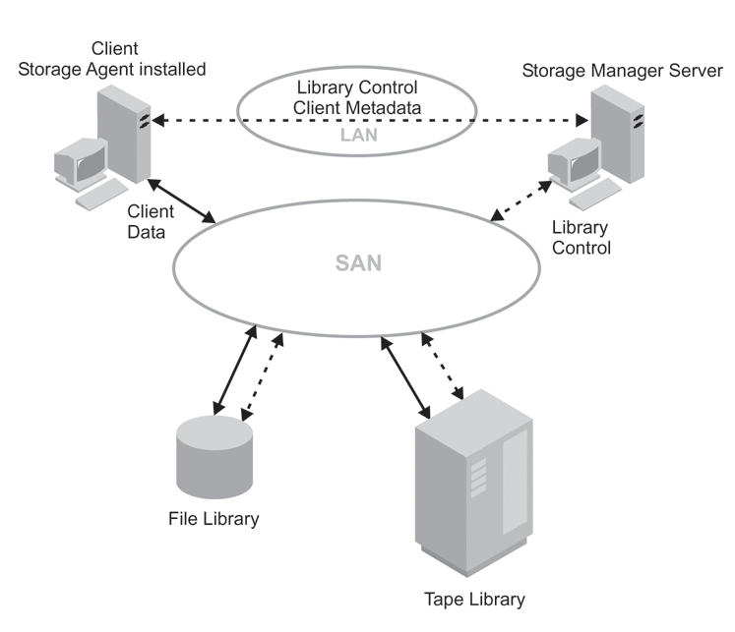

LAN-free data movement requires the installation of a storage agent on the client machine. The server maintains the database and recovery log, and acts as the library manager to control device operations. The storage agent on the client handles the data transfer to the device on the SAN. This implementation frees up bandwidth on the LAN that would otherwise be used for client data movement.

The following outlines a typical backup scenario for a client that uses LAN-free data movement:

1. The client begins a backup operation. The client and the server exchange policy information over the LAN to determine the destination of the backed up data.

For a client using LAN-free data movement, the destination is a storage pool that uses a device on the SAN.

1. Because the destination is on the SAN, the client contacts the storage agent, which will handle the data transfer. The storage agent sends a request for a volume mount to the server.
2. The server contacts the storage device and, in the case of a tape library, mounts the appropriate media.
3. The server notifies the client of the location of the mounted media.
4. The client, through the storage agent, writes the backup data directly to the device over the SAN.
5. The storage agent sends file attribute information to the server, and the server stores the information in its database.

If a failure occurs on the SAN path, failover occurs. The client uses its LAN connection to the Tivoli Storage Manager server and moves the client data over the LAN.

**Note:**

See the Tivoli Storage Manager home page at <http://www.tivoli.com/support/storage_mgr/tivolimain.html> for the latest information on clients that support the feature.

### [Server-Free Data Movement](http://publib.boulder.ibm.com/tividd/td/TSMCW/GC32-0782-00/en_US/HTML/anrwgd02.htm" \l "ToC_72)

Tivoli Storage Manager allows clients to directly back up and restore file system images between disk storage and tape devices accessible over a SAN. This server-free data movement is handled on behalf of the Tivoli Storage Manager server by an outboard data mover, such as the IBM SAN Data Gateway. The data mover must be able to execute the SCSI-3 extended copy command. Server-free data movers must have addressability to all the devices involved, which include disk and tape drives. The devices may be attached to the SAN through either direct Fibre-Attach or SCSI devices connected to a data mover.

Unlike traditional LAN and LAN-free backups and restores, data passes through neither the client nor the server. Instead, the data mover handles the data. In this way, backup and restore operations do not require resources from client or server processors or from the LAN. Because it will not be copying data, the Tivoli Storage Manager server can handle more concurrent client connections and server operations. In addition, the Tivoli Storage Manager client machine, not having to read and send data to the server, can handle a greater application load.

[Figure 5](http://publib.boulder.ibm.com/tividd/td/TSMCW/GC32-0782-00/en_US/HTML/anrwgd24.htm#FIGSRVFRDM) shows the movement of server-free data. The numbers (such as **(1)**) refer to numbers in the figure.

**Figure 5. Server-Free Data Movement**  
  


1. The client initiates a backup or restore image request (**(1)**).
2. The Tivoli Storage Manager server issues a mount request to the library (**(2)**).
3. The data mover initiates a copy operation (**(3)**).
4. The data is copied between the disk and the tape library (**(4)**).

Server-free operations transfer only volume images, not standard, file-level data. Images backed up by server-free data movement must be stored in storage pools with a data format of NONBLOCK. If the client cannot perform a server-free backup or restore, the operation fails over first to a LAN-free operation. If that operation cannot be performed, the client attempts a LAN-based backup or restore.

Server-free operations can restore LAN-based or LAN-free volume image backups. [Table 4](http://publib.boulder.ibm.com/tividd/td/TSMCW/GC32-0782-00/en_US/HTML/anrwgd24.htm#TBLFLOVR) describes the possible combinations.

**Table 4. Data Format Support**

|  |  |  |  |  |
| --- | --- | --- | --- | --- |
| **Data Format** | **LAN-Based Backup LAN-Free Backup** | **Server-Free Backup** | **LAN--Based Restore LAN-Free Restore** | **Server-Free Restore** |
| NATIVE | Yes | No | Yes | No |
| NONBLOCK | Yes | Yes | Yes | Yes |

The Tivoli Storage Manager for Windows 2000 client can perform a server-free image backup of both raw volumes and volumes that contain the NTFS file system. Tivoli Storage Manager allows users to perform full-volume backups of online volumes. The volume image version matches the volume at the start of the backup. Depending on the value of the IMAGEGAPSIZE client option, either all or only the used blocks of an NTFS volume are backed up.

The Tivoli Storage Manager client allows server-free backup and restore of volume images between different volume layouts with the exception of software-based RAID-5 volumes and software-striped volumes. When restoring to a software-based mirror volume (RAID-1), Tivoli Storage Manager restores to the primary copy only and uses the operating system to resynchronize the stale mirrors. The client supports volume layouts such as striped and mirrored only on Windows 2000 dynamic disks.

**Note:**

These restrictions apply only to software-based RAID levels, and not to storage subsystems that come with hardware RAID controllers.

Tivoli Storage Manager monitors the SAN addresses of devices it knows about. If the address of a defined devices changes due to an event on the SAN, the new address will be discovered and updated.

### [Planning for Server Storage](http://publib.boulder.ibm.com/tividd/td/TSMCW/GC32-0782-00/en_US/HTML/anrwgd02.htm" \l "ToC_73)

This section discusses how to evaluate your environment to determine the device classes and storage pools for your server storage.

Most devices can be configured using the Device Configuration Wizard in the Tivoli Storage Manager Console. The Device Configuration Wizard is recommended for configuring devices. See [Chapter 5, Configuring Storage Devices](http://publib.boulder.ibm.com/tividd/td/TSMCW/GC32-0782-00/en_US/HTML/anrwgd42.htm#HDRMANSCEN). The wizard can guide you through many of the following steps:

1. Determine the storage devices that are available to the server. For example, determine how many tape drives you have that you will allow the server to use.

The servers can share devices in libraries that are attached through a SAN. If the devices are not on a SAN, the server expects to have exclusive use of the drives defined to it. If another application (including another Tivoli Storage Manager server) tries to use a drive while the server to which the drive is defined is running, some server functions may fail.

1. Determine the device type and device class for each of the available devices. Group together similar devices and identify their device classes. For example, create separate categories for 4mm and 8mm devices.

**Note:**

For sequential access devices, you can categorize the type of removable media based on their capacity. For example, standard length cartridge tapes and longer length cartridge tapes require different device classes.

1. Determine how the mounting of volumes is accomplished for the devices:
   * Devices that require operators to load volumes must be part of a defined MANUAL library.
   * Devices that are automatically loaded must be part of a defined SCSI or 349X. Each automated library device is a separate library.
   * Devices that are controlled by StorageTek Automated Cartridge System Library Software (ACSLS) must be part of a defined ACSLS library.
   * Devices that are managed by an external media management system must be part of a defined EXTERNAL library.
2. If you are considering storing data for one Tivoli Storage Manager server using the storage of another Tivoli Storage Manager server, consider network bandwidth and network traffic. If your network resources constrain your environment, you may have problems using the SERVER device type efficiently.

Also consider the storage resources available on the target server. Ensure that the target server has enough storage space and drives to handle the load from the source server.

1. Determine the storage pools to set up, based on the devices you have and on user requirements. Gather users' requirements for data availability. Determine which data needs quick access and which does not.
2. Be prepared to label removable media. You may want to create a new labeling convention for media so that you can distinguish them from media used for other purposes.